**KWAME NKRUMAH UNIVERSITY OF SCIENCE AND TECHNOLOGY, KUMASI**

**COLLEGE OF ENGINEERING**

**DEPARTMENT OF GEOMATIC ENGINEERING**



**PROJECT TOPIC**

**IMPACT OF LAND USE LAND COVER CHANGES ON LAND SURFACE TEMPERATURE IN GREATER KUMASI**

**NAMES:** **ESSEL GIDEON (8175519)**

**ASENSO MICHAEL OPPONG (8173919)**

**SUPERVISOR: DR.YAW MENSAH ASARE**

**MR. ELISHA AKANLO ANANKANSA**

**YEAR: AUGUST, 2023**

# DECLARATION

We hereby declare that this thesis is a product of my own and to the best of my knowledge, it contains my original work and no previous material publication by another person, except for instances where due references and acknowledgment has been given in the text. The content of this work has not been submitted to any other University or tertiary institution for an award of any degree, diploma, or certificate in either Ghana or abroad. I have also acknowledged any assistance that has contributed to the success of this thesis.

Essel Gideon (8175519) ……………... ………………  
(Student Name & ID) Signature Date

Asenso Michael Oppong (8173919) ……………... ………………  
(Student Name & ID) Signature Date

Certified By:  
Dr. Yaw Mensah Asare .…..………… ………………  
Supervisor Signature Date

Certified By:  
Prof.Jonathan Quaye Ballard …….……... .....................  
Head of Department Signature Date

# DEDICATION

This project is lovingly dedicated to God, and all who through even their subtlest efforts made this degree a reality.

# ACKNOWLEDGEMENT

We want to acknowledge God for the utmost grace and glory He gives us throughout our daily activities. Our second appreciation goes to our supervisor; Dr. Yaw Mensah Asare, for his wonderful guidance and supervision throughout this project.

We really appreciate the time we had and the data provided to us by the various organizations we approached. They have been really helpful throughout this project. Our special gratitude also goes to our guidance who have supported us throughout our program of study, their encouragement, and words of perseverance also saw us through the successful completion of this project.

Thank you to all our Lecturers, Technicians, and Teaching Assistants in the Department of Geomatic Engineering for their immersing academic training throughout our years of stay at KNUST.

# ABSTRACT

The change of land use and land cover (LULC) has a substantial influence on the modification of the local climate, particularly in connection to the Land Surface Temperature (LST), which may be thought of as the temperature of the earth's surface. This project's goal is to investigate the effects of changes in land use and land cover (LULC) on land surface temperature (LST), with a particular emphasis on gaining an understanding of the dynamic relationship that exists between the actions of humans and the natural processes that influence the temperature distribution on the land surface. In order to study the relationships that may exist between the various types of land use and the Land Surface Temperature (LST) values associated with those uses, a combination of remote sensing technologies, Geographic Information Systems (GIS), and statistical analysis are used. The purpose of this study is to get a better understanding of the effects that changes in land use and land cover (also known as LULC) have on thermal conditions. These changes include things like the loss of vegetation, the expansion of urban areas, the cutting down of forests, and the expansion of agricultural production. The findings point to a significant association between changes in land use and land cover and variations in the temperature of the land's surface. This finding highlights the critical necessity of implementing sustainable land management practices in order to mitigate the effects of urban heat islands and adapt to the effects of climate change. In addition, this research provides a potential set of policies and practices for land-use planning that may be implemented in the future in order to reduce the likelihood of rises in land surface temperature (LST).

# TABLE OF CONTENTS

DECLARATION ii

DEDICATION iii

ACKNOWLEDGEMENT iv

ABSTRACT v

TABLE OF CONTENTS vi

LIST OF TABLES ix

LIST OF FIGURES x

CHAPTER ONE 1

INTRODUCTION 1

1.1 Background of Study 1

1.2 Problem statement 4

1.3 Research Questions 5

1.4 Aim and Objectives 5

1.5 Justification for the study 6

1.6 Thesis Organization 6

CHAPTER 2 7

Literature Review 7

2.1 Concept of Land Use and Land Cover 7

2.2 Land Surface Temperature 9

2.3 Relationship between Land Use Land Cover and Land Surface Temperature. 13

2.4 Land Use Land Cover Change Affecting LST in Kumasi 15

2.5 GIS And Remote Sensing 16

2.6 Using Remote Sensing to Determine LST In Land Use Land Cover 19

2.7 Remote Sensing Techniques and Data Sources 20

2.7.1 Sensors on Satellites 21

2.7.2 Airborne Platforms 22

2.7.3 Additional Sources for Obtaining Data 22

2.8 Image Classification 23

2.9 Empirical Review of Impact of LULC on LST. 27

2.10 Theoretical Review 29

2.11 Conceptual Framework on the Impact of LULC on LST 31

CHAPTER THREE 38

METHODOLOY 38

3.1 Study area 38

3.2 Methods 39

3.3 Data acquisition 41

3.4 Softwares used in the study 42

3.5 Data preprocessing 43

3.6 Classification scheme 43

3.7 Image classification 44

3.8 Rate of change of land use land cover 46

3.9 Accuracy assessment 47

3.9.1 Land surface temperature calculation 47

3.9.1.1 Calculation of TOA (Top of Atmospheric) spectral radiance. 47

3.9.1.2 Brightness Temperature conversion 47

3.9.1.3 NDVI calculation 48

CHAPTER FOUR 49

RESULTS AND DISCUSSION 49

4.1 Introduction 49

4.2. LULC Changes 49

4.3 LST Variations 52

4.4 Relationship between LULC and LST 53

4.5 NDVI Relationship with LST 55

4.5 Accuracy Assessment 58

4.6 Discussion of Findings 58

CHAPTER FIVE 60

CONCLUSION AND RECOMMENDATIONS 60

5.1 Conclusion 60

5.2 Summary of Findings 61

5.2 Recommendations 62

REFERENCES 64

# LIST OF TABLES

Table 3.1 Data sources characteristics 40

Table 4.1 Validation and Accuracy Assessment 57

# LIST OF FIGURES

Figure 3.1 Map of study area (Source: Authors’ Construct,2023) 38

Figure 4.1 Supervised Classified Map of LULC 49

Figure 4.2 Area Covered by LUCL Classes 50

Figure 4.3 Graph of the area covered plotted against LULC classes 50

Figure 4.4 Classified map of LST of KMA 51

Figure 4.5 Variations of LSTs in Different Land Covers 52

Figure 4.6 Graph depicting the Relationship Between mean LST and Land Cover Indices 53

Figure 4.7 NDVI Maps for the years 2012 and 2022 55

Figure 4.7 Correlation map of NDVI against LST , 2012 56

Figure 4.7 Correlation map of NDVI against LST, 2022 56

# CHAPTER ONE

# INTRODUCTION

## 1.1 Background of Study

Evaluations pertaining to changes in land use and land cover (LULC) are currently being used in numerous places throughout the world for the goal of monitoring and successfully managing ecological transitions (Akomolafe and Rosazlina, 2022). The concept of "land use" encompasses the diverse range of human activities undertaken on land, which have the potential to modify the flora, water features, soil composition, geological formations, and other natural resources within a given geographical area. A thorough understanding of the land use and land cover (LULC) within a specific region is required for the efficient implementation of land management strategies meant to address related issues. Understanding historical, current, and future changes in land use and land cover (LULC) can help improve a comprehensive assessment of the socioeconomic and ecological consequences of these changes (Sateesh and Sandip, 2011). Changes in land use and land cover, according to Zaidi et al. (2017), can be attributed to a rise in human activity on a global scale as well as the phenomenon of urbanization. Human activities are rapidly affecting the plant cover of terrestrial ecosystems, resulting in environmental changes at multiple scales, including local, regional, and global (Kikon et al., 2016). Surface temperature has risen as a result of the transformation of vegetation covers to alternative land use patterns, including the presence of open surfaces, impermeable surfaces, and agricultural areas (Sahana and Sajjad, 2016; Zhang et al., 2013). The increase in population and inadequate or insufficiently controlled management of land use and land cover changes in urban areas are factors that contribute to the phenomenon of global climate change, resulting in elevated surface temperatures. Therefore, evaluating LULC changes in a region will help people understand how much and where anthropogenic changes have occurred (Kikon et al., 2016). According to Pal and Ziaul (2017), it is well accepted that the evaluation of terrestrial surface features, specifically land use and land cover (LULC), is closely related to land surface temperature. Several studies have used remote sensing techniques to examine the impact of land use and land cover (LULC) on land surface temperature (LST) in various places throughout the world. According to Uddin et al. (2013), using satellite remote sensing and geographic information systems allows for the assessment of the amount of human influence on ecosystems by assessing land use and land cover changes as well as vegetation indices across time. The use of remote sensing technology has been proven to facilitate and reduce the cost of retrieving data relevant to vegetation and land use/land cover (LULC) modifications within a specified geographical area and time frame (Wang et al., 2020).Then, utilizing GIS tools, these spatial data may be accurately handled and evaluated. Landsat sensors, including the Landsat 5 Thematic Mapper (TM), Landsat 7 Enhanced Thematic Mapper (ETM), and Landsat 8 Operational Land Imager (OLI), were used to assess land use and land cover (LULC) and vegetation indices.. An area's LST can be studied to learn more about the likelihood of human survival there. Due to the negative effects of harsh climatic conditions on crop growth, survival, and productivity, it might also reveal information about crop survival. The use of Landsat data, namely Landsat 8, has greatly improved the examination of land surface temperature (LST) at both the local and regional levels. The normalized difference vegetation index (NDVI) has been used to assess vegetation dynamics and presence, including measures like the green leaf area index, vegetation cover, green biomass, and vegetation productivity. Usman et al. (2014) describe a study that provides insights into the current status of vegetation and predicts plant productivity in various locations throughout the world. The Normalized Difference Vegetation Index (NDVI) is based on electromagnetic radiation principles, which state that the presence of photosynthetic pigments reduces light reflection in the visible spectrum, particularly in the green light range. As a result, the object's near-infrared reflectance reaches its maximum. The purpose of this study was to look into the effects of changes in land use and land cover (LULC) on land surface temperature (LST) in Greater Kumasi from 2012 to 2022. Kumasi has undergone considerable developmental changes as a result of rapid industrialization and several human-induced variables. It has been proposed that undertaking detailed research on historical climate trends and land use changes in a given location can allow for more accurate projections of these elements' potential future implications. As a result, it became critical to assess the effects of these human-caused changes on the flora of this well-known urban region. As a result, the primary goals of this research are to assess land use and land cover (LULC) changes in the Greater Kumasi area over an 10-year period, analyze changes in land surface temperature (LST) and normalized difference vegetation index (NDVI), and investigate the relationship between LST and NDVI in relation to the various LULC classes. The purpose of this study was to look at the impact of changes in land use and land cover (LULC) on land surface temperature (LST) in the Greater Kumasi region from 2012 to 2022. Over the course of time, the city of Kumasi has experienced significant developmental changes as a result of fast industrialisation and many human-induced factors. It has been suggested that conducting a study on historical climate and land use changes in a certain region can contribute to a more accurate understanding of the potential impacts of these elements in the future. As a result, it became critical to analyze the effects of these anthropogenic changes on the vegetation of the well-known urban environment. As a result, the primary goals of this study are to assess changes in land use and land cover (LULC) in the Greater Kumasi region over a ten-year period, examine fluctuations in land surface temperature (LST) and normalized difference vegetation index (NDVI), and investigate the relationship between LST and NDVI in relation to various LULC classifications.

## 1.2 Problem statement

Land surface temperature (LST) measurement is critical in the fields of soil science, hydrology, biology, and geochemistry for analyzing the exchange of surface materials, the balance of surface energy, and the various physical and chemical processes occurring at the surface (Tomlinson et al., 2011; Hao et al., 2016). Land use and/or land cover changes (LULC) have a significant impact on LST. Different land use types have different surface reflectivity and roughness, which causes variances in LST. (Deng et al., 2018). Additionally, Greater Kumasi's human activity intensity is increased as a result of urbanization, and the surface cover is changing quickly (Li et al., 2017). To better understand the ecological implications of land surface temperature (LST) and to successfully address regional environmental concerns, it is critical to research the relationship between LST and land use and land cover (LULC). The presence of vegetation can have a significant impact on land surface temperature (LST) via a variety of mechanisms, such as the regulation of latent and sensible heat exchange, selective absorption and reflection of solar radiation energy, and absorption and reflection of solar radiation energy. According to Yuan et al. (2017), various approaches that rely on thermal infrared remote sensing data to reliably estimate land surface temperature (LST) have been proposed by both local and international specialists. Many scientists in modern academia employ remote sensing techniques to study the relationship between land surface temperature (LST) and land use trends. However, there are still several issues and gaps in the current studies that require attention. Different research techniques, such as determining land surface temperature directly from brightness temperature, have been used, which has decreased data accuracy. Additionally, the majority of prior research focused on the impact of urbanization-related land changes and the urban heat island effect on LST in these cities, with large cities serving as the primary study regions(Lu et al., 2021). The link between land surface temperature and LULC in Greater Kumasi areas, which are distinguished by distinctive geographical features and a delicate biological environment, has only been the subject of a small number of research(Jiang and Tian, 2010). Land surface temperature (LST) measurement is critical for understanding the underlying environmental dynamics and associated physical and chemical processes in the Greater Kumasi region. More research is needed to determine the influence of changing land use and cover on land surface temperature in the Greater Kumasi region.

## 1.3 Research Questions

1. What changes in land use and land cover have been detected within the chosen research area?
2. What is the relationship between changes in land use and land cover and changes in land surface temperature?
3. What is the most effective way to determine changes by comparing various maps?

## 1.4 Aim and Objectives

The goal of this research is to create a detailed map of the land use, land cover, and land surface temperature patterns in the Greater Kumasi region. The study intends to detect any changes that have occurred, analyze their influence on land surface temperature, and then estimate prospective changes that may occur within a defined timeframe by examining data from various historical periods. The specific objectives are as follows;

1. To classify land use and land cover in Greater Kumasi.
2. To determine the effect of land use and land cover changes on land surface temperature
3. To Detect changes in land use land cover by comparing land use land cover maps.

## 1.5 Justification for the study

Prior attempts at tracking Kumasi's development involved aerial photography and other surveying methods. Due to the dynamics of land use land cover and in particular settlement expansion in the area, a more potent and complex system such as GIS and Remote Sensing data, which delivers a broad comprehensive synoptic coverage of vast areas than aerial photography is now required.

## 1.6 Thesis Organization

The current report is divided into five chapters. The first chapter begins with an introductory section that covers the setting, objectives, problem description, research questions, and scope of the study. The second chapter gives a thorough examination of the existing body of literature. The third chapter provides an overview of the topic matter and research methodology. The fourth chapter of the study discusses the acquired results, while the fifth chapter presents the conclusions and references.

# CHAPTER 2

# Literature Review

## 2.1 Concept of Land Use and Land Cover

Although the terms "land cover" and "land use" (LULC) are sometimes used interchangeably, it is critical to recognize that these concepts refer to distinct entities (Firdaus, 2014). According to the Food and Agriculture Organization of the United Nations (2005), the phrase "Land Use" refers to how people interact with land, with a particular emphasis on the economic value of the land in relation to various activities. In contrast to this is the concept of land cover, which outlines the physical characteristics and external manifestation of the land surface and provides a tangible picture of land usage (Darlrymple et al., 1992). This idea of land cover is in opposed to the idea of land cover. Different forms of land cover include a wide variety of possible arrangements, activities, and resources that may be employed to provide socioeconomic and cultural benefits.

Land use is often inferred from the observed cover, hence the visibility and identifiability of land cover in the field is frequently larger than that of land use. This is due to the fact that land cover is more easily observed. Regardless of this, it is vital to recognize that these concepts are tightly tied to one another and are commonly addressed together in the context of mapping in order to reduce the likelihood of any confusion arising (Ibe and Quelennac, 2011). According to Holt et al. (2009), the complex interaction that exists between land cover and land use can make it tricky to differentiate between the two categories. This is because it can be difficult to discern the causal link that exists between the two. However, it is essential to keep in mind that modifications in land use and land cover occur predominantly as a consequence of human actions that directly impact the physical environment (Crowell et al., 2010). This fact has to be taken into consideration. According to Hendry and Digafeldtk (2017), over the course of human history, people have sought to increase the productivity and usability of land by modifying or converting the land's natural vegetation in order to serve a variety of objectives. According to Harris and Ventura (2006), since the beginning of humankind's ability to manipulate their surroundings, one of the most significant aspects of the interaction between humans and their environments has been the modification of land use and land cover (LULC). To get a handle on this procedure, you will need to conduct extensive research and think carefully about it. Analyzing how land cover has changed over time is an important step in determining how changes in land use and land cover (LULC) have occurred. According to Forkour et al. (2014), this methodology requires the systematic monitoring of changes over a predetermined time period as well as the identification of a variety of land cover classifications. According to Giri et al. (2007), the previously described approach makes it easier to comprehend the temporal evolution of a variety of systems as well as the influence that natural occurrences and human activities have on these systems. Numerous studies on land use and land cover (LULC), such as the study that was carried out by Gyawali et al. (2014), have considerably helped the process of identifying places that are suffering a loss in land resources as well as those that are being conserved. This stage is critical in the context of protecting land resources. Koranteng et al. (2017) claim that changes in land cover have a significant impact on both the biotic and abiotic constituents of many ecosystems around the world. The terrain has been significantly altered as a result of human activity, which has led to a number of severe ecological repercussions.

Change detection is a method that may be used to determine whether or not there has been a shift in the current state of phenomena that has been repeatedly observed at predetermined intervals (Singh, 1989). In order to facilitate urban growth and ensure efficient administration and monitoring of natural resources, it is essential to make use of this technique. Additionally, it is essential to ensure effective use of natural resources. The identification of changes makes it possible to conduct a quantitative analysis of the spatial distribution of the population that is being investigated. According to Macleod and Congation (1998), there are four critical aspects of change detection that are particularly important in the context of natural resource monitoring:

1. The identification of the underlying element that is accountable for the remarkably changed state.
2. An analysis of the way in which the change is distributed throughout space
3. An evaluation of the area affected by the change, expressed as a numerical value

The investigation of temporal shifts and the extrapolation of prospective patterns are both covered in this topic. The exploitation of remote sensing data for the purpose of change detection is premised on the core concept that changes in land cover have an influence on radiance values, which may be identified through remote methods. This is the underlying justification for this line of reasoning. Because of the adaptive nature of digital data processing and the development that has been made in computer capacity, it is now viable to use satellite images for the purpose of change detection. The development of several technologies that can identify changes in satellite images has been made easier as a result of this.

## 2.2 Land Surface Temperature

The phrase "Land Surface Temperature" (LST) refers to the quantification of the thermal condition of the Earth's surface, a characteristic that can be measured using orbital remote sensing technologies. This temperature can be expressed in degrees Celsius. The ramifications of this phenomena have far-reaching repercussions on our comprehension of climate change, environmental monitoring, agricultural practices, urban growth, and emergency management. According to Nichol (1996), the land surface temperature (LST) is an essential property that has a significant influence on a variety of processes and interactions that occur within the Earth system. Several different technical approaches, including as sensors based on satellites, weather stations located on the ground, and portable infrared thermometers, can be used to determine the Land Surface Temperature (LST). According to Jiménez-Muoz and Sobrino (2016), the employment of satellite-based sensors is popular in the collecting of Land Surface Temperature (LST) data on a worldwide scale. This finding was made possible by advancements in technology. In a broad sense, the function of these sensors is to determine the amount of radiant energy that is emitted by surfaces within the range of thermal infrared radiation. Researchers can calculate the land surface temperature (LST) by using known mathematical connections that link the temperature of the Earth's surface to the emitted radiation from that surface. Weng (2009) elaborated on how the connections described in this context were generated from satellite measurements. Climate patterns found on the Earth's land surface are influenced by a variety of variables. According to Sellers (1985), the amount of solar radiation reaching the Earth's surface plays a critical role in regulating the planet's energy absorption and subsequent temperature. According to Lillesand et al. (2008), different types of land cover, such as forests, deserts, urban areas, and aquatic bodies, have distinct thermal characteristics that influence the land surface temperatures (LSTs) of their particular locations. Land surface temperature (LST) is calculated using several surface properties such as albedo, emissivity, and thermal inertia. The combined effects of these elements are what contribute to the LST as a whole (Schmugge, 1985). At the surface of the Earth, the existence of clouds, water vapor, and other components of the atmosphere can have an effect on the solar radiation that arrives there and the thermal radiation that leaves there. As a result, these changes have the potential to influence the temperature of the Earth's surface (Stephens et al., 1990). The use of land surface temperature (LST) is a method that is widely used across many academic areas. LST data is used in a variety of academic disciplines, including climate studies, urban planning, agricultural operations, and environmental monitoring. The use of satellite-derived land surface temperature (LST) data is extremely important in the analysis and monitoring of temporal fluctuations in land surface temperatures, particularly in climate change and global warming studies (Hansen et al., 2001). This is due to the fact that LST data may be obtained from satellites. The amassing of this data is of critical importance for determining the current state of the warming of the planet's atmosphere and achieving a deeper, more meaningful comprehension of the myriad ways in which climate change is affecting various parts of the world. According to Oke (1982), the phenomenon known as the metropolitan Heat Island (UHI) is defined by temperatures that are much higher in urban areas than in nearby rural areas. The analysis of data pertaining to land surface temperature (LST) is critical in the context of the exploration of the phenomenon of the Urban Heat Island (UHI). The findings of Arnfield's (2003) research have significant implications, not only for municipal planning practices but also for the prevention of heat stress in densely populated metropolitan areas. According to Mildrexler, Zhao, and Running (2011), the exploitation of LST data possesses the potential to deliver substantial information into the health of crops, the amount of water stress they are under, as well as growth trends. Consequently, this technology may be of considerable assistance in the monitoring of agricultural operations and the assessment of the health of crops. The use of this technology makes it easier for farmers to evaluate the effect that extreme weather events have on agricultural output and to optimize the irrigation strategies they employ. According to Townshend and Justice (1986), using data from Land Surface Temperature (LST) in the field of natural resource management makes it easier to observe changes in land cover, assess the extent of deforestation, and enhance management of natural resources. According to Running et al. (2004), this method makes it easier to assess the state of an ecosystem and gain a better knowledge of how ecosystems react to alterations in their surrounding environment. It is of the highest significance to acquire Land Surface Temperature (LST) data in order to support emergency response and disaster management efforts in the context of natural disasters. These natural disasters include, but are not limited to, wildfires, droughts, and heatwaves, among others. According to Lillesand, Kiefer, and Chipman (2014), using this tool makes the process of identifying impacted locations, evaluating the extent of the losses sustained, and formulating strategies for the execution of relief activities more efficient. According to Kalnay et al. (1996), the introduction of Land Surface Temperature (LST) data into weather and climate models has the goal of improving the accuracy of weather forecasts and predicting the occurrence of severe weather occurrences. Due to the fact that it may be used to such a broad variety of different fields, the measurement of Land Surface Temperature (LST) holds a significant amount of weight within the discipline of Earth science. Because of the incorporation of measurements that were acquired from satellites, our capacity to monitor and interpret the fluctuations in the temperature of the Earth's surface has been substantially enhanced. This has made it possible for better informed decisions to be made in the areas of environmental management and sustainable development. The use of cutting-edge technology and the expanding availability of precise Land Surface Temperature (LST) data present us with potentially fruitful possibilities to develop our understanding of the interrelationships between the Earth's climate and its many elements. According to Froelking et al. (2006), the improved knowledge that may be obtained as a result of this research has the potential to make a meaningful contribution toward the more efficient management of environmental challenges.

## 2.3 Relationship between Land Use Land Cover and Land Surface Temperature.

In the fields of environmental science, urban planning, and the study of climate change, one of the most complicated and well-researched topics is the connection between the land use land cover (LULC) and the land surface temperature (LST). It is essential to have a solid understanding of this connection in order to devise efficient methods for the control of urban heat, the mitigation of climate change, and the building of sustainable urban design. The phrase "land use" refers to the actions and behaviors carried out by humans on a particular plot of land. These actions and behaviors might range from farming to building houses. The term Land Use and Land Cover (LULC) refers to how humans use terrestrial areas (land use) and the physical and biological qualities that envelop the Earth's surface (land cover).This contains the many ways in which LULC may be described. According to Verburg et al. (2011), the previously described components are dynamic and are subject to ongoing change as a direct result of human activities such as urbanization, deforestation, agricultural practices, and industrialization. The temperature at the surface of the Earth is referred to as the Land Surface Temperature (LST), and it plays a significant role in a variety of environmental studies and modeling endeavors. The influence of a large number of variables on land surface temperature (LST) includes both natural features such as surface albedo, plant type, and soil moisture, as well as changes brought about by humans such as urbanization and changes in land use (Weng et al., 2004). The conversion of rural areas into urban environments is one of the most remarkable human-caused shifts. There is a large body of data demonstrating a substantial relationship between changes in land use and land cover (LULC) and changes in land surface temperature (LST). This phenomena is exemplified when the number of urbanized or developed areas increases, which frequently results in changes in both land use and land cover. As a result, land surface temperatures (LST) continue to rise. The thermal qualities of natural surfaces like forests and grasslands are not the same as those of urban surfaces like concrete, asphalt, and buildings. These surfaces have the capability to take in and store more heat, which they later release back into the environment, leading to an increase in the land surface temperature (LST). The impact in the issue is referred to as the Urban Heat Island (UHI) effect, and it was originally recognized by Oke in the year 1982.When compared to urban areas, the land surface temperatures (LSTs) in places that are characterized by the presence of vegetation, such as wooded areas, parks, and agricultural fields, are often lower. It has been shown that the presence of vegetation lowers the land surface temperature (Bonan, 2002). This is because of the process of evapotranspiration, which involves the transfer of water from the land to the atmosphere according to Zhou et al. (2013), the link between land use and land cover (LULC) and land surface temperature (LST) is not exactly linear. Instead, it can vary based on factors such as regional and temporal timeframes, local meteorological conditions, and the particular types of land use and land cover that are present. Because of their large heat capacity as well as their ability to both store and move heat, water bodies also contribute to the regulation of the Land Surface Temperature (LST). The use of remote sensing techniques is extremely important to the research that is being done on the correlation between land use and land surface temperature (LULC-LST). When investigating the relationship that exists between variables at a variety of spatial and temporal resolutions, satellite data, such as that which can be obtained from the Landsat series, is a resource that is particularly useful. The study described above contributes to a better understanding of urban heat islands, the development of solutions to mitigate the effects of climate change, and the promotion of sustainable urban design (Zhou et al., 2013).In a nutshell, the connection between land use and land cover (also known as LULC) and land surface temperature (also known as LST) is a complex and ever-changing one. Gaining an understanding of this link is crucial for a number of different sectors, including the prevention of climate change, urban planning, and environmental management. It is necessary to do further research in order to design strategies that are tailored to a certain location in order to effectively regulate the heat in urban areas and mitigate the consequences of climate change.

## 2.4 Land Use Land Cover Change Affecting LST in Kumasi

The process of urbanization has frequently resulted in significant changes in land use and land cover (LULC) in various metropolitan areas experiencing rapid growth around the world, such as Kumasi. As urban areas expand and progress, there is frequently a decline in the availability of natural green spaces and a corresponding increase in the extension of built-up areas. Changes in land use and land cover (LULC), which involve the replacement of vegetation with urban infrastructure such as concrete, asphalt, and other man-made structures, can have a substantial impact on regional climate, particularly through increasing land surface temperature (LST). The observed phenomenon can be primarily ascribed to the discrepancy in heat capacity and thermal properties demonstrated by natural and artificial surfaces. Urban areas demonstrate a phenomenon referred to as the Urban Heat Island effect, whereby urban structures possess a tendency to absorb and retain a larger quantity of heat throughout the daytime, subsequently emitting it during the nighttime. In comparison to the surrounding rural areas, urban areas have higher temperatures. Regions with extensive vegetation, on the other hand, play an important role in moderating the urban heat island effect by boosting evapotranspiration and providing shade. As a result of the reduction of these vegetated areas, the process of urbanization is expected to elevate Land Surface Temperature (LST). Furthermore, the use of satellite remote sensing data, specifically from the Landsat series or MODIS, has the potential to have a significant impact on the understanding of changes in Land Use and Land Cover (LULC) and their implications for Land Surface Temperature (LST) in Kumasi during the specified timeframe. This methodology would allow for the examination of changes in land use and land cover (LULC) across many temporal and spatial dimensions, as well as their relationship with land surface temperature (LST).The examination of the relationship between land use and land cover (LULC) and land surface temperature (LST) necessitates a careful examination of the complexities and fluctuations that may arise as a result of many factors. This analysis includes the distinct characteristics of the regional climate, the specific land cover and land use patterns within the area, and the geographical resolution used for the study.

## 2.5 GIS And Remote Sensing

Although the idea of remote sensing has been defined in a variety of ways across a number of different books, its core components have remained mostly unchanged. The United Nations defined remote sensing in 1986 as the process of monitoring the surface of the Earth from a great distance in space by making use of the properties of electromagnetic waves that are generated, reflected, or diffracted by a variety of different objects. According to the United Nations (1986), the implementation of this technique makes it possible to improve the management of natural resources, the usage of land, and the protection of the environment. According to Lillesand et al. (2008), the scientific and artistic process of acquiring information about an object, area, or phenomenon by analyzing data obtained from a device that does not physically interact with the object, area, or phenomenon being studied is referred to as remote sensing (Lillesand et al., 2008, p.1). This definition was provided by Lillesand et al. (2008). The study of satellite or aerial photography is at the heart of the field of remote sensing, a branch of science that relies on the detection of electromagnetic signature changes to distinguish and discriminate between various types of land use and land cover on Earth. It is standard practice to combine geographic information systems (GIS) and remote sensing techniques. The term "Geographic Information Systems" (GIS) refers to the practice of applying scientific methods to successfully use geographic data for the purpose of displaying, analyzing, and exploring information that is intimately related to specific geographical areas. This may be accomplished by properly utilizing geographic data. The use of techniques that involve remote sensing makes it possible to acquire and disseminate data in a more expedient manner across a large geographical area. The aforementioned techniques include the use of sensors that are able to operate in a number of different spectral bands simultaneously. These sensors are installed aboard either airplanes or satellites. Aerial photography was the inaugural use of remote sensing technology, which can be traced back to the 1930s. This is also the earliest known instance of its use. Studies that are conducted simply on individual plots have limitations that may be overcome by using this approach (Goslee et al., 2003). The employment of this methodology makes it possible to facilitate the recognition of spatial patterns over broader geographical extents. According to Lillesand and Kiefer (2000), the idea of "remote sensing" refers to the process of acquiring data on an item or feature by the analysis of information obtained by a device that does not make physical contact with the object or feature being inspected. In other words, remote sensing is a method of gathering information about an object or feature by analyzing information gathered by a device. The increased use of remote sensing may be attributed to the requirement for a robust system to analyze the effects of stress on natural resources, which has resulted in the increased employment of such technology. The traditional methods of collecting and evaluating environmental data typically reveal inefficiencies, particularly when it comes to providing the necessary information in a timely and cost-effective manner. Because of this, the practice of monitoring Earth from the vantage point of space has become very necessary in order to appreciate the cumulative effect that human activities have had on the natural resources of the planet. When compared to other methods, the use of remote sensing technology provides a faster, more efficient, and less expensive way to gather information that is accurate and reliable. Because a multispectral sensor is able to take several photographs of the same target item at a variety of wavelengths, or bands, it can facilitate the measurement of diverse spectral features connected to the target. The term "spectral band" refers to a dataset collected by a sensor that incorporates information gathered from various parts of the electromagnetic spectrum. This data may be broken down into many spectral bands. The electromagnetic spectrum includes all forms of electromagnetic radiation, from gamma rays to radio waves, and comprises a wide range of this energy. In the electromagnetic (EM) spectrum, multispectral sensors are built to particularly target regions where radiation may efficiently travel through the Earth's atmosphere with minimum absorption by the desired target. This is accomplished by designing the sensors to specifically target certain regions. The remote sensors that are placed on space platforms have been designed to work during predetermined time intervals. During these time periods, they make use of detectors that have been calibrated to catch particular wavelength frequencies that are able to penetrate the Earth's atmosphere.

## 2.6 Using Remote Sensing to Determine LST In Land Use Land Cover

The field of remote sensing has undergone considerable advancements throughout time, allowing for a more comprehensive and evidence-based understanding of the Earth's surface. Remote sensing is an incredibly significant component of the Land Use and Land Cover (LULC) assessment due to its contribution to the facilitation of the determination of Land Surface Temperature (LST). It offers a method that is both extremely effective and non-intrusive, making it suitable for monitoring and researching large geographical areas over lengthy periods of time. The capacity of satellite-based remote sensing to provide uninterrupted geographical and temporal coverage is one of the primary reasons why it is so useful in the study of Land Surface Temperature (LST). The radiation that is released by the Earth may be measured by satellites like as Landsat, MODIS, and ASTER thanks to the thermal infrared sensors that are installed on those satellites. Weng (2009) conducted research that indicated that radiation emissions can be converted into temperature data. Researchers can gain valuable insights into the impact of different land use and land cover categories on surface temperature by using remote sensing techniques. This is accomplished by combining data on land surface temperature (LST) and data on land use and land cover (LULC).

The information that was gathered has the ability to shed light on a number of different linkages that are crucial. One instructive example is to urban areas, which are characterized by the preponderance of concrete and asphalt and are usually connected to increased land surface temperatures (LST) as a result of the urban heat island effect (Zhou & Wang, 2011). Urban areas are also differentiated by the predominance of concrete and asphalt, which contribute to the urban heat island effect. On the other hand, it is important to keep in mind that areas with vegetation and water bodies have the potential to bring about a cooling effect due to processes such as evapotranspiration (Kumar & Shekhar, 2015). This is something that should be taken into consideration. It is essential to recognize the usefulness of remote sensing as a technique for analyzing Land Surface Temperature (LST) as well as Land Use and Land Cover (LULC). However, in order to ensure an accurate interpretation of the data, it is required to carry out calibration and correction procedures with the utmost care. This includes the procedure of atmospheric correction, which is utilized to adjust for the influence of atmospheric gases and aerosols on the radiation that has been measured (Sobrino & Raissouni, 2000). In addition, it is frequently necessary to undertake ground-truthing or validation using in-situ measurements in order to verify the dependability of the land surface temperature (LST) values that are produced from remote sensing (Dash et al., 2002). This is because ground-truthing and validation are two methods that may help ensure that the LST readings are accurate. There are numerous Land Use and Land Cover (LULC) scenarios, and it is obvious that remote sensing is a feasible alternative for measuring Land Surface Temperature (LST) in each of these cases. The continuous advancement of data processing technology and methods will have a significant impact on research in the disciplines of climate studies, land management, and environmental science. These technological advancements are expected to have a substantial impact on their respective fields of study.

## 2.7 Remote Sensing Techniques and Data Sources

In the study of the relationships between Land Use Land Cover (LULC) and Land Surface Temperature (LST), several remote sensing techniques and data resources are routinely used. These methods give researchers useful information at different regional and time scales, which helps them figure out how changes in land cover and surface temperature affect each other. Here are some of the most important ways that LULC-LST projects use remote sensing and data sources:

### 2.7.1 Sensors on Satellites

1. **Multispectral Sensors:** Multispectral sensors on satellites record data in multiple separate spectral bands. Based on their unique spectral fingerprints, they are often used to find and sort different types of land cover. instruments on the Landsat series, Sentinel-2, and MODIS (Moderate Resolution Imaging Spectroradiometer) are all examples of multispectral instruments.
2. **Thermal Infrared Sensors:** Thermal infrared sensors, also called thermal sensors or TIR sensors, measure the thermal infrared light given off by the Earth's surface. They give important information about the temperature of the land's surface, which is important for understanding the effects of urban heat islands and climate change. The Thermal Infrared Sensors on Landsat and MODIS are two examples.
3. **Hyperspectral Sensors:** These sensors collect data in many narrow spectral bands that are close together. This lets you do a more thorough spectral analysis and tell different types of land cover apart. They can be used to classify LULC in a fine-grained way and find changes. Sensors like Hyperion on EO-1 and the planned HyspIRI (Hyperspectral Infrared Imager) mission are two good examples.
4. **Synthetic Aperture Radar (SAR):** SAR devices work in the microwave range and can take pictures in any weather, day or night. Since microwave waves can go through clouds and plants, they can be used to map ground cover in places where there are a lot of clouds or a lot of plants. SAR data can also be used to look at changes in the roughness of the surface, like how cities grow. Sensors like those on Sentinel-1 and RADARSAT are good examples.

### 2.7.2 Airborne Platforms

1. **Airborne Lidar:** Airborne Lidar (Light Detection and Ranging) systems use laser beams to measure the distance between the plane and the Earth's surface. It gives high-resolution elevation data, which can be used to map landforms and figure out how land cover and urban areas are changing. Lidar data can also be used to measure the height of the canopy and the structure of the plants.
2. **Aerial photography:** This is when high-resolution pictures of the Earth's surface are taken from the air. It is often used for thorough LULC mapping and figuring out what different kinds of land cover look like by looking at them. You can also learn a lot about how land cover has changed over time by looking at old aerial photos.

### 2.7.3 Additional Sources for Obtaining Data

1. **Unmanned Aerial Vehicles (UAVs):** UAVs, also known as "drones," are a flexible and cost-effective way to collect high-resolution images on a local scale. They are used more and more in LULC-LST studies to make accurate maps, especially in places that are hard to get to or have rough terrain.
2. **Ground-Based monitors:** Weather stations and temperature monitors on the ground are used to verify and measure data from remote sensing. This makes sure that the data is accurate and reliable for LST studies. By putting together data from different tools and platforms, researchers can get a full picture of LULC-LST links and what they mean for managing the environment, planning cities, and adapting to climate change. Having multi-temporal and multi-sensor information makes these kinds of studies more accurate and useful.

## 2.8 Image Classification

The idea of characterizing a picture refers to the process of categorizing individual pixels, which are the essential building blocks of digital images. This approach is frequently used in the field of remote sensing, where the purpose is to classify similar pixels discovered in remotely sensed data into classes that fit with application-specific categories (Schowengerdt, 2007). The use of this methodology is widespread in this particular field. Pixels are evaluated in respect to one another and to other pixels that are already known to have certain characteristics as part of the process of comparing pixels. The goal of this evaluation is to place pixels into the category that best describes them based on a predetermined set of criteria.Pixel categorization may be broken down into one of two basic subcategories: supervised classification and unsupervised classification. According to Auzet (2008), researchers in the subject frequently utilize these two methodologies. When using supervised classification, a significant amount of reliance is placed on the analyst's level of experience in the particular field of interest as well as the availability of adequate data to properly reflect the spectral properties of the various classes. According to Richards and Jia (2006), in order to drive the classification process, the analyst selects certain cover types that are then referred to as training areas. This method makes it possible to organize pixels into the classes to which they belong in a manner that is both more controlled and more exact. In contrast, the method of unsupervised classification, which is also known as clustering, includes the spectral division of image data by statistically grouping the numerical data (Digital Number - DN values) that are present in the picture (Tso & Mather, 2009). Clustering is also known as the process of unsupervised classification. Clustering is also known as the process of unsupervised classification. Although using this method reduces the dependence on the analyst's skills, the analyst is still responsible for deciding how many categories or classes should be applied to the dataset. In addition, it is possible that the analyst will need to take into consideration the possibility of the requirement to combine or divide specific categories that were formed by the classifier. Because of this, despite the fact that it is called "unsupervised classification," it does not entirely remove the need for the involvement of humans in the classification process. When confronted with detailed diversity in the spectral response pattern of certain cover categories, researchers frequently turn to an approach known as "hybrid classification," which combines various classification techniques (Lillesand & Kiefer, 2014). This method combines many classification techniques. This technique is shown to be particularly useful in situations in which there is a significant amount of variation among the different types of cover and the features of the site. The amount of control that is exercised during unsupervised classification is laxer in comparison to that which is exercised during supervised classification. The patterns that have been seen or impacted by information from a variety of sources are reflected in the pixels that have been selected for this method. Before choosing the training sets, it is essential to have a complete grasp of the material, the classes that are wanted, and the algorithms that will be used. Only then can you make an informed decision. According to Mather and Tso (2016), computer systems are able to go through a process known as "training" in order to recognize patterns within symbols, which enables these systems to differentiate between pixels that have similar characteristics. The pattern of a pixel may then be controlled once it has been designated to a certain class, and at the same time, a value that corresponds to the class can be designated to the pixel. The interpretation of remotely sensed data requires a number of critical components, including both supervised and unsupervised classifications. These components facilitate the comprehension and analysis of patterns linked to land use and land cover. The selection of a particular strategy is dependent on the particular requirements that are being satisfied by the study that is being carried out, and every methodology comes with its own unique set of benefits and drawbacks. The idea of "image characterization" refers to the categorization of pixels, which function as the fundamental building blocks of digital photographs. It is common practice in the field of remote sensing to make use of this approach, with the intention of grouping related pixels found in remotely sensed data into categories that are in accordance with the specific needs of the application (Schowengerdt, 2007). Evaluation of pixels in respect to one another and comparison of those evaluated pixels to other pixels with known attributes are both part of the process of pixel comparisons. This makes it possible to assign pixels to the category that best fits them, depending on a set of criteria that had been decided upon beforehand. Pixel categorization may be broken down into one of two basic subcategories: supervised classification and unsupervised classification. According to Auzet (2008), researchers in the subject frequently utilize these two methodologies. The success of supervised classification is dependent not only on the analyst's level of knowledge in the particular field but also on the extent to which the data that is readily accessible are capable of adequately portraying the spectral features of the various classes. According to Richards and Jia (2006), the classification process is directed by the analyst's choice of certain cover types, which are referred to as training areas. This approach makes it possible to classify pixels into the categories that correspond to them in a way that is more accurate and under control. On the other hand, the method of unsupervised classification, which is often referred to as clustering, includes the spectral division of image data by statistically grouping the numerical data (Digital Number - DN values) discovered within the picture (Tso & Mather, 2009). Clustering is also known as the process of unsupervised classification. Although using this method reduces the dependence on the analyst's experience, the analyst is still responsible for identifying the appropriate number of categories to apply to the dataset in order to get the best results. In addition, the analyst may need to take into consideration the possibility that certain categories that were created by the classifier will need to be combined or divided. Therefore, contrary to its nomenclature, unsupervised classification does not entirely eliminate the need for the involvement of a human being in the classification process. When dealing with detailed variability in the spectral response pattern for certain cover categories, the use of a method known as "hybrid classification" is used (Lillesand & Kiefer, 2014). This strategy demonstrates its value most clearly in circumstances in which there is a great deal of variation in terms of the types of cover and the features of the site. The amount of control that is exercised during unsupervised classification is laxer in comparison to that which is exercised during supervised classification. The patterns that have been seen or impacted by information from a variety of sources are reflected in the pixels that have been selected for this method. Before choosing the training sets, it is essential to have a complete grasp of the material, the classes that are wanted, and the algorithms that will be used. Only then can you make an informed decision. Mather and Tso (2016) state that it is feasible to educate computer systems to discriminate between pixels that exhibit similar features by recognizing patterns in symbols. This is something that can be done by training the computer system. When a pixel has been designated for a class, the pattern that it produces is controlled, and at the same time, a value that corresponds to the class is given to the pixel.

## 2.9 Empirical Review of Impact of LULC on LST.

The Influence of Land Use and Land Cover (LULC) on Land Surface Temperature (LST): A Review of the Literature Investigation into the connection between Land Use and Land Cover (also known as LULC) and Land Surface Temperature (also known as LST) has been the subject of a significant amount of empirical study. These studies (Foley et al., 2005; Turner II et al., 2007) have shown that shifts in LULC have a significant influence on temperature trends at both the local and regional levels. The Urban Heat Island (UHI) effect is a well-documented phenomena that offers empirical evidence for the higher average temperatures experienced in urban areas in comparison to the surrounding rural regions (Oke, 1987). The Urban Heat Island (UHI) effect is a well-documented phenomenon that offers empirical evidence for the higher average temperatures experienced in urban areas. increasing rates of heat absorption and lower cooling effects of evapotranspiration have led to increasing temperatures in urban areas as a result of the conversion of natural surfaces to impermeable materials such as concrete and asphalt (Taha, 1997). These changes have resulted in heightened temperatures in urban regions.

One discovery based on empirical research that offers an alternative viewpoint relates to areas that are characterized by a plentiful amount of flora. According to Pickett et al. (2011), the presence of green spaces like parks and woods has been discovered to be an effective technique of moderating the Urban Heat Island (UHI) effect. This was shown to be the case when the researchers tested this hypothesis. According to Bonan (2008), trees help to bring temperatures down by casting shade and promoting the evaporation of moisture from the air. These two factors work together to have this effect. According to Carlson and Ripley (1997), vegetation is responsible for a variety of activities that contribute to the cooling of the surface of the planet. Some of these processes include the reflection and absorption of solar radiation, as well as the processes of water transpiration and evaporation. A previous study (Foley et al., 2005) has provided evidence that there is a significant amount of variation in the effects that different forms of land use and land cover (LULC) have on the average temperature of the Earth's surface. According to Kustas and Anderson (2009), empirical research reveals that water bodies such as lakes and rivers, which contain a substantial heat capacity, have a major cooling impact, successfully regulating temperatures. These water bodies include both freshwater and saltwater bodies of water. On the other hand, it has been discovered that the presence of bare soil and surfaces with limited permeability results in the retention of heat, hence increasing the rise in temperature (Seto et al., 2011). This was the finding of the researchers who conducted the study. According to Stewart and Oke (2012), the ever-changing nature of both climate and terrain can have an impact on the impacts that land use and land cover (LULC) have on land surface temperature (LST). According to Seto et al. (2011), there is empirical data showing that the urban heat island (UHI) effect has a tendency to be more visible in regions that are characterized by dense populations and considerable urban growth. According to Lambin and Meyfroidt (2011), empirical research has established that changes in land cover have a noticeable effect on regional climate patterns, which in turn initiates feedback processes that exert an influence on temperature. Climate change may have been a contributing factor in the beginning of these feedback loops. Deforestation, for instance, has the ability to lessen the effect of local cooling while simultaneously adding to the general trends of global warming (Bonan, 2008). In order to mitigate these consequences, there is empirical evidence for a variety of urban planning and design methods, such as the expansion of green spaces, the implementation of cool roof technology, and the inclusion of sustainable land use practices (Pickett et al., 2011). These measures include the addition of green spaces, the adoption of cool roof technology, and the incorporation of sustainable land use practices. It is of the utmost significance to have an understanding of the complexities involved in the relationship that exists between land use and land cover (LULC) and land surface temperature (LST). According to Turner II et al. (2007), the findings may be subject to a degree of variance based on factors such as geographical location, the time frame, and any other pertinent variables. (Foley et al., 2005; Seto et al., 2011) It is recommended that in order to get a complete knowledge of this subject matter, one should do a thorough investigation of a variety of scientific journals, databases, and contemporary academic publications that deal to this field of research. This will allow one to obtain a full understanding of the subject matter.

## 2.10 Theoretical Review

A Theoretical Framework for Investigating the Influence of Changes in Land Use and Land Cover (LULC) on the Temperature of the Land Surface. The following presents the theoretical underpinnings adopted for the study. The idea argues that changes in Land Use/Land Cover (LULC) have a direct influence on the Land Surface Temperature (LST), as stated by Foley et al. (2005). According to the findings of Turner II et al. (2007), the predicted impact of human activities such as urbanization, deforestation, agriculture, and natural processes on land use and land cover (LULC) is likely to have a significant influence on the temperature of the earth's surface. Having an understanding of land use and land cover (LULC) Land Use refers to the intended use of a certain area of land, which can include a wide variety of activities such as residential, agricultural, or recreational uses of the land. On the other hand, Land Cover refers to the qualities that can be seen on the surface of the Earth. This includes the presence or absence of numerous elements such as farmed regions, urban infrastructure, bodies of water, and forests (Foley et al., 2005). According to a number of different theoretical models, changes in land use and land cover (LULC), which can be brought on by urbanization, deforestation, or degradation of land, have the ability to bring about modifications in the temperature of the land's surface (Lambin & Meyfroidt, 2011). These changes can also bring about changes in the microclimate. The grasp of Land Surface Temperature, often known as LST, is essential to the study of events that occur on land surfaces at both the regional and the global levels. According to Kustas and Anderson (2009), it has an effect on the absorption of both longwave and shortwave radiation as well as the emission of both types of radiation. An increased land surface temperature (LST) may be used as an indicator for the existence of urban heat islands, which are characterized by noticeably higher temperatures in urban districts in comparison to the temperatures in the surrounding rural areas (Oke, 1987). An urban heat island can be distinguished from other types of heat islands by its elevated land surface temperature (LST). The connection between land use and land cover, also known as LULC, and land surface temperature, also known as LST: The relationship between LULC and LST is complex and may be broken down into a number of different categories. According to Seto et al. (2011), the process of urbanization, which involves the conversion of natural land cover into built-up areas, almost always leads in an increase in land surface temperature (LST), which in turn gives birth to urban heat islands. Urbanization also entails the conversion of natural land cover into built-up areas. On the other hand, according to Bonan (2008), areas that have a lot of flora, such as forests or agricultural fields, tend to have lower average surface temperatures. This is because of a process called evapotranspiration, which happens when a lot of water evaporates into the air. Within the scope of this part, we shall investigate a variety of theoretical viewpoints that are pertinent to the subject at hand. The study adopted two

a) According to Oke (1987), the theory of the Urban Heat Island Effect proposes that an increase in Land Surface Temperature (LST) is caused by the process of urbanization, which entails the change of natural land cover into artificial surfaces. Because of a decrease in vegetation and an increase in impermeable surfaces, the observed phenomena may be ascribed to a lower ability for evapotranspiration to cool the environment and an improved capacity for heat absorption (Taha, 1997). This can be linked to a rise in temperatures.

b) According to the hypothesis of deforestation and land degradation, a rise in Land Surface Temperature (LST) occurs when plant cover is lost as a result of deforestation or degradation of land. According to Lambin and Meyfroidt (2011), this rise can be linked to a decrease in the amount of shade as well as the cooling impact of evapotranspiration. According to the plant Canopy Cover Theory, an increase in the amount of plant cover has the ability to lower the Land Surface Temperature (LST) by facilitating the process of evapotranspiration. This theory was developed in the 1970s. This technique is quite successful in dissipating heat, which ultimately results in the surface becoming cooler (Bonan, 2008).

## 2.11 Conceptual Framework on the Impact of LULC on LST

Land Use/Land Cover (LULC) pertains to the categorization and characterization of diverse land types and their utilization within a specified geographic region. The variables that have been referenced, namely Built-Up, Vegetation, Water, and Barren Land, are fundamental elements in the process of Land Use and Land Cover (LULC) mapping and analysis. Let us engage in a comprehensive examination of each of these elements in the context of Land Use and Land Cover (LULC).

1. **Built Up:** Urbanized land encompasses regions that have undergone human intervention, resulting in the establishment of residential, commercial, industrial, and infrastructure projects. Illustrative instances encompass municipalities, villages, thoroughfares, edifices, and additional elements of the urban landscape. The comprehension of urban expansion, population density, and the environmental and natural resource implications of urbanization heavily relies on the analysis of built-up areas. The monitoring and management of built-up areas play a crucial role in facilitating sustainable urban planning and resource allocation.
2. **Vegetation:** Vegetation encompasses diverse forms of plant life, such as forests, grasslands, croplands, and shrublands, that occupy and adorn different geographical regions. The analysis of land use and land cover (LULC) is a crucial component that has a direct impact on ecological and environmental processes. The presence of vegetation supports the existence of various forms of wildlife, aids in the preservation of biodiversity, facilitates the sequestration of carbon, and assumes a pivotal function in the regulation of the climate. The assessment of landscape impacts resulting from deforestation, afforestation, and agricultural practices can be facilitated through the monitoring of vegetation changes.
3. **Barren land:** refers to regions characterized by a scarcity of vegetation cover and minimal human habitation. These regions may encompass arid deserts, exposed rock formations, and other infertile terrains. The inclusion of barren land in land use and land cover (LULC) analysis is imperative due to its ecological significance and potential impact on regional climate patterns. The comprehension of alterations in arid landscapes is of utmost importance in the investigation of desertification and its ramifications on adjacent habitable areas.

The classification and mapping of land use and land cover (LULC) types often rely on the utilization of remote sensing data obtained from satellites or aerial imagery. The comprehension of the spatial distribution and temporal dynamics of these variables holds significant importance for a range of applications, including but not limited to urban planning, environmental conservation, disaster management, and natural resource management. The provision of precise and reliable land use and land cover (LULC) data is crucial for decision-makers in formulating effective and sustainable policies and strategies aimed at tackling environmental issues and fostering responsible land utilization methods. The term "Land Surface Temperature" (LST) pertains to the measurement of the temperature of the Earth's surface, which can be obtained through the use of satellite or ground-based instruments. The aforementioned variables, namely Climate Changes, Health Effects, Ecosystems, and Human Activities possess the potential to exert substantial influences on Land Surface Temperature (LST). The study would undertake a comprehensive examination of each individual item under consideration.

1. **Climate Change:** The phenomenon of climate change, specifically the processes of global warming and the urban heat island effect, can exert a substantial impact on land surface temperature (LST). The rise in global temperatures associated with climate change results in a general augmentation of Land Surface Temperature (LST). The increase in temperatures has the potential to impact the occurrence and severity of heat waves, resulting in heightened levels of extreme heat occurrences within both urban and rural regions. Variations in land surface temperature (LST) have the potential to influence regional climatic conditions, the availability of water resources, and the consumption of energy. The monitoring of Land Surface Temperature (LST) is of utmost importance in comprehending the ramifications of climate change and evaluating the effects of heat stress on urban communities.
2. **Health Implications:** Elevated Land Surface Temperature (LST) can potentially result in detrimental health consequences for human populations. Heatwaves and extended periods of elevated temperatures have the potential to induce heat-related ailments, including heatstroke, heat exhaustion, and dehydration. Certain populations, including the elderly, children, and individuals with pre-existing medical conditions, are particularly susceptible to heightened vulnerability. The utilization of Land Surface Temperature (LST) data is of utmost importance in the identification of regions susceptible to high temperatures and the subsequent implementation of public health interventions aimed at mitigating the adverse health effects associated with extreme heat events.
3. **Ecosystems:** The influence of LST on ecosystem dynamics is of utmost importance. The phenomenon has an impact on the distribution, growth, and reproductive patterns of plant and animal species. Extreme heat events have the potential to induce physiological strain on vegetation, leading to diminished productivity and heightened susceptibility to wildfires. Alterations in land surface temperature (LST) can have significant repercussions on aquatic ecosystems, exerting influences on water temperatures and the viability of aquatic species. The monitoring of Land Surface Temperature (LST) is crucial in order to comprehend the susceptibility of ecosystems to the impacts of climate change and human activities.
4. **Impact of Human Activities:** The influence of human activities, particularly urbanization and changes in land use, can have a significant effect on Land Surface Temperature (LST). Urban areas exhibit higher land surface temperatures (LST) in comparison to the adjacent rural areas, primarily as a consequence of the urban heat island (UHI) phenomenon. The substitution of natural surfaces with impermeable materials such as concrete and asphalt results in elevated heat absorption and diminished evapotranspiration, thereby contributing to the escalation of land surface temperature (LST). Deforestation, agricultural practices, and industrial activities have the potential to induce changes in Land Surface Temperature (LST) within particular geographical areas. A comprehensive comprehension of the correlation between human activities and land surface temperature (LST) is imperative in the context of sustainable urban planning and land management.

In brief, the Land Surface Temperature (LST) serves as a pivotal metric for comprehending the ramifications of climate change, evaluating potential threats to public health, observing the fluctuations in ecosystem dynamics, and effectively managing the processes of urbanization and land utilization. The provision of accurate and comprehensive information aids policymakers and researchers in making well-informed decisions aimed at effectively addressing the various challenges presented by increasing temperatures, while also fostering resilience within both human and natural systems.

**External Factors**

1. **Climate change:** is a phenomenon characterized by enduring alterations in the Earth's climate, predominantly instigated by human activities, particularly the release of greenhouse gases. The warming of the Earth's climate results in an elevation of Land Surface Temperature (LST). Increased global temperatures lead to heightened land surface temperature (LST) values, particularly in the context of heat waves and extreme weather occurrences. The phenomenon of climate change has the potential to amplify the urban heat island effect, thereby exacerbating the occurrence of heat stress within urban environments.
2. **Solar radiation:** plays a crucial role in influencing land surface temperature (LST) as it emanates from the Sun. The Sun emits energy in the form of shortwave radiation, thereby resulting in the heating of the Earth's surface. Throughout the diurnal cycle, various surfaces undergo the process of solar radiation absorption, resulting in a subsequent elevation in temperature. Surfaces characterized by a high albedo, or reflectivity, exhibit a greater capacity to reflect solar radiation, resulting in lower land surface temperatures (LST). On the contrary, surfaces characterized by low albedo exhibit a greater capacity to absorb radiation, resulting in elevated land surface temperature (LST) values.
3. **The velocity of wind:** has the potential to impact land surface temperature (LST) by means of convective heat transfer. When wind traverses the Earth's surface, it facilitates the removal of accumulated heat from said surface, thereby inducing a cooling effect. Increased wind velocities have the potential to augment the cooling phenomenon, thereby resulting in decreased Land Surface Temperature (LST) values. Conversely, tranquil or minimal wind conditions can facilitate the accumulation of heat, resulting in elevated land surface temperatures (LST).
4. **Impact of humidity:** on land surface temperature (LST) is mediated by the process of evapotranspiration. In conditions of high humidity, the atmosphere possesses an increased quantity of moisture, thereby facilitating the process of evaporation from various sources on the Earth's surface, such as vegetation. The process of evapotranspiration has the effect of cooling the surface, thereby leading to a reduction in land surface temperature (LST). In areas characterized by elevated humidity levels, the land surface temperature (LST) tends to exhibit a lower magnitude in comparison to arid regions characterized by diminished humidity levels, where LST can manifest notably higher values.

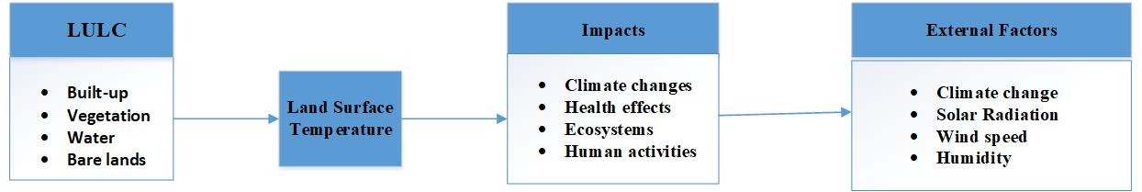

***Figure 2.1 Conceptual framework of the study (Source: Author’s Construct,2023)***

# CHAPTER THREE

# METHODOLOY

## 3.1 Study area

The Kumasi Metropolitan Area is believed to be 214 square kilometers in size and is located between latitudes 06°ﹾ35" and 060°04"N and longitudes 01°ﹾ30". The district is bounded to the south by the Bosomtwe District, to the east by the Ejisu-Juaben Municipality, to the west by the Atwima Kwanwoma and Atwima Nwabiagya Districts, and to the north by the Kwabre District. According to current forecasts, the population will number 1,517,000. The annual rate of growth is 2.5%. The overall land area is 214 square kilometers, with a specific portion of 15,920 hectares designated as arable land. The total land area dedicated to agricultural agriculture measures 11,930 hectares, representing approximately 74.9% of the overall farmland that is now accessible. The region exhibits a diversified landscape of land ownership, encompassing various forms such as stool ownership, leasehold, family property, and share cropping, which are structured under the Abunu or Abusa system. Nevertheless, it is important to acknowledge that the accessibility of farmland is constrained due to extensive infrastructural development, which is rapidly encroaching into agricultural areas. Consequently, sedentary agriculture has emerged as a more favorable choice for agricultural practices in the region.Greater Kumasi's vegetation is found in the South-East Ecological zone's moist semi-deciduous region. The Kumasi metropolitan region is located in a sub-equatorial climate zone, with average temperatures ranging from 21.5°C to 30.7°C. The average annual precipitation is 625 meters, with large surges in June and September, measuring 214.3 and 16.2 millimeters, respectively. The precipitation distribution is mostly favorable and equitable. At 9:00 GMT and 15:00 GMT, the humidity is generally 84.16% and 60%, respectively. The Forest Ochrosol is the main type of soil in the Metropolis. The Metropolitan region's dominant geological formation is the middle Precambrian Rock. The area in question is located on a plateau with elevations ranging from 250 to 300 meters above sea level, specifically in the South-West region. The topography is mainly undulating in character. Subin, Wewe, Susan, Aboabo, Oda Owabi, Suntre, Akrubu, Acheamponmene, and Asuoyeboa are a few of the city's well-known rivers and streams.

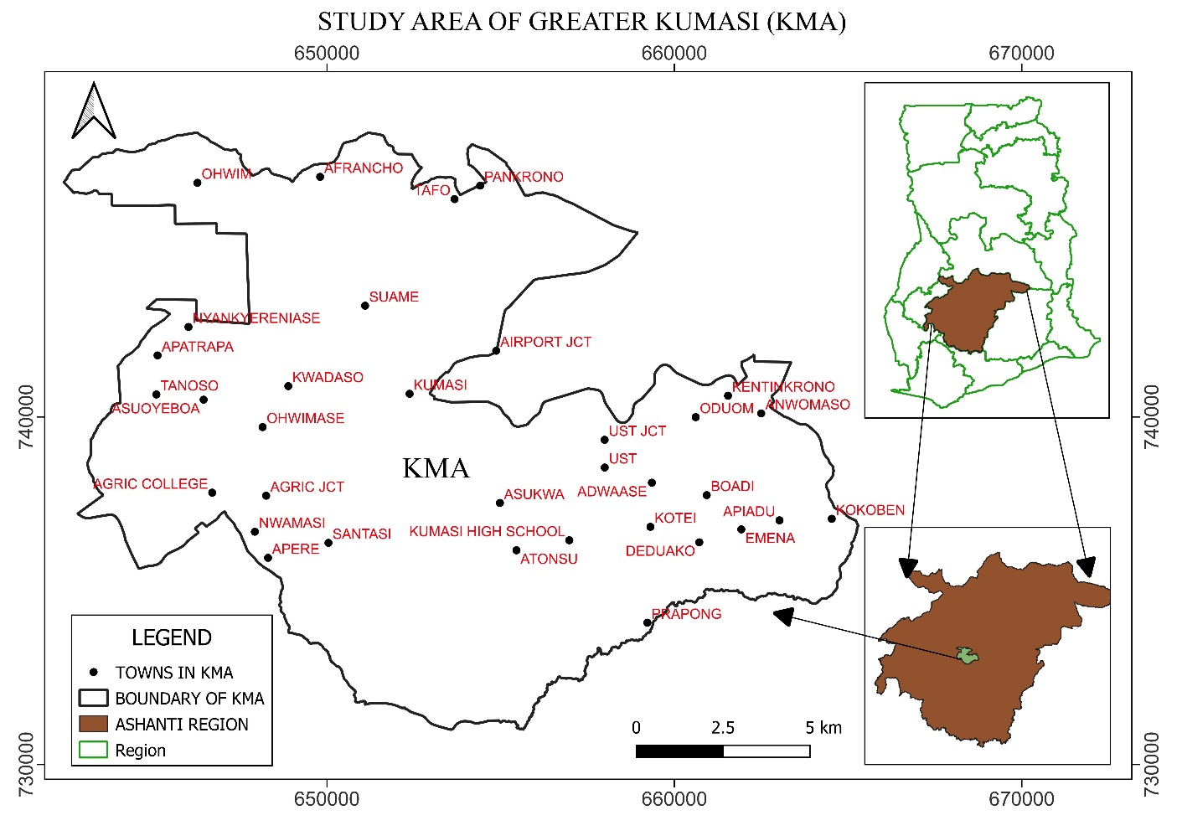

Figure 3.1 Map of study area (Source: Authors’ Construct,2023)

## 3.2 Methods

This chapter explains the approach used in this study to achieve the aforementioned goal.

The flowchart depicts the overall sequence of steps used in this study to acquire statistical data on the land use pattern of the chosen area.

## 3.3 Data acquisition

Using Landsat satellite pictures, an analysis of changes in land use, temperature at the ground surface, natural disaster risk index, and natural disaster vulnerability index was carried out in Greater Kumasi. These pictures were taken over a period of ten years, beginning in 2012 and ending in 2022, and they all have the same degree of resolution. As a result, it was beneficial to conduct an analysis of the changes and patterns that took place over the time period that was being looked at. The photographs that were discussed before were taken from the United States Geological Survey's (USGS) official website, which may be accessed at https://earthexplorer.usgs.gov. After that, they were aligned with the World Geodetic System 1984 datum and georeferenced using the Universal Transverse Mercator (UTM) projection. More precisely, they were georeferenced in UTM zone 30N. The photographs were altered so that they could be processed further by having their formats changed to TIFF. In addition to that, a summary of the attributes of the image was given. The table that follows provides a summary of the data that was obtained, including the production dates and resolutions that correspond to each set of data.

Table 3.1 Data sources characteristics

|  |  |  |  |  |  |
| --- | --- | --- | --- | --- | --- |
| Satellite | Path/Row | Sensor | Number of bands | Date captured by sensor | Spatial Resolution |
| Landsat 8 | 194/55 | OLI_TIRS | 11 | 2012-07-11 | 30M |
| Landsat 8 | 194/55 | OLI_TIRS | 11 | 2022-01-22 | 30M |

## 3.4 Softwares used in the study

1. **QGIS and ArcGIS:** Both are Geographic Information System (GIS) software that are used to visualize, analyze, and interpret geographical data. They play a key role in remote sensing by aiding in the management and analysis of geospatial data. In our project, we used them for creating shapefiles, which are popular geospatial vector data formats for GIS software. Shapefiles can be used to represent any spatial data like points, lines, or polygons. They were also used in processing coordinate points, which might involve geo-referencing, feature extraction, or data conversion tasks. Lastly, we utilized these software for producing land use and land cover maps, which are critical in understanding the landscape and its changes over time.
2. **ERDAS Imagine:** This is a digital image processing software mainly used in the remote sensing community. Its functionalities range from image enhancement, image classification, to change detection. We used ERDAS Imagine for processing of the images. This could involve a range of tasks from noise reduction, radiometric correction, atmospheric correction to more advanced processes like supervised or unsupervised classification.
3. **Google Earth Pro**; It is a geospatial software application that displays a 3D representation of Earth based on satellite imagery. In our project, it was used to pick the coordinate points for the classes. This could be a part of ground truthing process, where you might identify known features in the landscape and note their coordinates for validation or training purposes in image classification.
4. **Microsoft Excel:** A spreadsheet software that is widely used for data management and statistical analysis. In the context of our research, Microsoft Excel was used to produce a bar graph. This might be for visually representing data statistics or results of your analysis. It could help in understanding data patterns, trends, or to provide a clear, visual summary of the findings.
5. **Microsoft Word**: This is a widely used word processing software. For our project, it was primarily used for presenting the research. This involved writing the methodology, results, discussion, and conclusions of our research. Also, we used it to format our research findings according to a specific style or template, insert tables, figures, or citations.

## 3.5 Data preprocessing

The Landsat pictures from each year were extracted and then utilized to generate a composite band image layer by layer stacking the.tiff files. This was done so that the photos could be used for comparison purposes. The procedure of integrating the information required the utilization of a method known as mosaicking to accomplish the task. After superimposing and intersecting the shapefile of the study with the shapefile of Greater Accra, the focal area of the study was established. Radiometric correction, which is analogous to haze correction, was applied to the images before they were published. Since all of the shots utilized the same coordinate system and had the same level of spatial resolution, none of the images were altered geometrically in any way.

## 3.6 Classification scheme

It is uncommon to find precisely specified classes that one would desire in practically any classification procedure. To make categorization simpler, the land cover classes should be known before to gathering training samples. The specific land cover classifications utilized are listed in the table below.

|  |  |
| --- | --- |
| Land cover classes | Description |
| Built up Land | consists of the urban structure, the industrial, commercial, and transportation facilities, the mines, the construction sites, the dumps, and the man-made non-agricultural vegetated areas. |
| Vegetation/ Agric. land | Permanent crops, pastures, heterogeneous agricultural regions, other vegetation, and agricultural farmlands are all types of agricultural land. |
| Bare Land | Beaches, dunes sands, bare rocks, open places with little or no vegetation, and sparsely vegetated areas |

## 3.7 Image classification

Supervised classification methods have a reputation for delivering superior accuracy when compared to unsupervised classification methods, due to the directed, learning-based nature of the former. Supervised classification involves training a model on a set of labelled data and then applying that model to classify unlabeled data into different categories. In the context of this project, this approach was adopted to partition satellite imagery into various classes, representing diverse land use changes.

The classification model chosen for this project was the Maximum Likelihood Classifier (MLC). As a statistical classification method, MLC estimates the probability that a pixel belongs to a particular class. These probability calculations are based on the statistical characteristics of the training data for each class. Ultimately, each pixel is assigned to the class with the highest probability (or maximum likelihood).

The analysis was performed following a series of methodical steps:

1. **Selection of Training Areas:** The first step involved delineating the Areas of Interest (AOIs) for training the classifier. These AOIs were designed to encircle the coordinate points of the diverse classes identified through Google Earth Pro. Google Earth Pro facilitated the extraction of geospatial coordinates from different land use classes, providing a spatially accurate base for selecting the training data.
2. **Generation of the Signature File:** Following the selection of AOIs, the spectral signatures associated with each class were generated and recorded in a signature file. These signatures, or unique reflectance patterns across various wavelengths, act as identifiers for each land use class. The signature file, therefore, becomes an integral part of the supervised classification, providing the necessary data that aids in differentiating among various classes.
3. **Performance of Supervised Classification**: The final step involved applying the Maximum Likelihood Classifier to the satellite imagery using the previously generated signature file. Each pixel within the imagery was then categorized into one of the land use classes based on its spectral signature, with the highest likelihood determining its class assignment.

Thus, through the rigorous process of supervised classification, it became feasible to transform raw satellite imagery into interpretable land use maps, offering a clear vision of the land use changes that have occurred.

## 3.8 Rate of change of land use land cover

The difference in area coverage between the second and first years was calculated to determine the extent of change for each land use/land cover class, as shown in the provided equation.

The magnitude is calculated by subtracting the magnitude of the new year from the magnitude of the previous year.

As shown in the equation below, the percentage change (trend) for each land use and land cover (LULC) category was calculated by dividing the magnitude of change by the sum of changes between the relevant years and then multiplying the result by 100.

Trend = (magnitude of change/ sum of change) *100

The formula below was used to estimate the rate of change of forest cover and the land use pattern between 2012 and 2022.

Rate of Change (%) = [(a2/a1)1/n−1] ×100 (Pandit, 2011)

Where a1 = Base year data

a2 = end time data

n = number of years

## 3.9 Accuracy assessment

On the basis of the classification results of Landsat photos, accuracy assessment of the image classification was carried out using the supervised classification, and Kappa coefficient error matrices were calculated.

### 3.9.1 Land surface temperature calculation

To calculate or obtain the land surface temperature the formula below was adopted

LST = (BT/(1+(0.00115*BT/1.4388)*Ln(Ꜫ)))

3.9.1.1 Calculation of TOA (Top of Atmospheric) spectral radiance.

TOA (L) = ML * Qcal + AL

where:

ML = Band-specific multiplicative rescaling factor from the metadata (RADIANCE_MULT_BAND_x, where x is the band number).

Qcal =Band10  
AL = Band-specific additive rescaling factor from the metadata (RADIANCE_ADD_BAND_**x**, where x is the band number).

3.9.1.2 Brightness Temperature conversion

BT = (K2 / (ln (K1 / L) + 1)) − 273.15

where:

K1 = Band-specific thermal conversion constant from the metadata (K1_CONSTANT_BAND_**x**, where x is the thermal band number).  
K2 = Band-specific thermal conversion constant from the metadata (K2_CONSTANT_BAND_**x**, where x is the thermal band number).

L = TOA

Therefore, to obtain the results in Celsius, the radiant temperature is adjusted by adding the absolute zero (approx. -273.15°C).

3.9.1.3 NDVI calculation

NDVI = (Band 5 – Band 4) / (Band 5 + Band 4)

Calculation of the NDVI is important because, subsequently, the proportion of vegetation (Pv), which is highly related to the NDVI, and emissivity (ε), which is related to the Pv, must be calculated.

NDVI = (Band 5 – Band 4) / (Band 5 + Band 4)

1. **Calculate the proportion of vegetation Pv**

Pv = Square ((NDVI – NDVImin) / (NDVImax – NDVImin))

1. **Calculate Emissivity ε**

ε = 0.004 * Pv + 0.986

LST = (BT / (1 + (0.00115 * BT / 1.4388) * Ln(ε)))

# CHAPTER FOUR

# RESULTS AND DISCUSSION

## 4.1 Introduction

This chapter aims to expound upon the discoveries gleaned from our research and delve into the direct impact of alterations in Land Use and Land Cover (LULC) on Land Surface Temperature (LST). The results distinctly highlight the manner in which various types of land use and cover influence land surface temperature. This chapter does not merely present these findings but goes a step further to deeply analyze them. In the subsequent sections, the study aligns the outcomes of the results with existing research, ensuring a coherent understanding of these environmental issues. By doing so, significant connections are drawn between the findings and their implications for the environment. This chapter presents a comprehensive and coherent overview of our study's findings and their environmental implications.

## 4.2. LULC Changes

The study's findings, illustrated in the classified map (refer to Figure 4.1), reveal a significant increase settlement areas from 2012 to 2022. This suggests substantial growth in urban development and human activities, such as the construction of residential and commercial buildings, industrial developments, and infrastructure expansion. In parallel with these changes, we observed a marked reduction in vegetation cover and bare land (See Figure 4.2), which is likely linked to the increase in built up or settlement. Land clearance activities associated with urban and infrastructural development align with these observations. While natural factors may have contributed to these results, the simultaneous expansion of settlements leads us to infer that human activity is likely the dominant contributor.

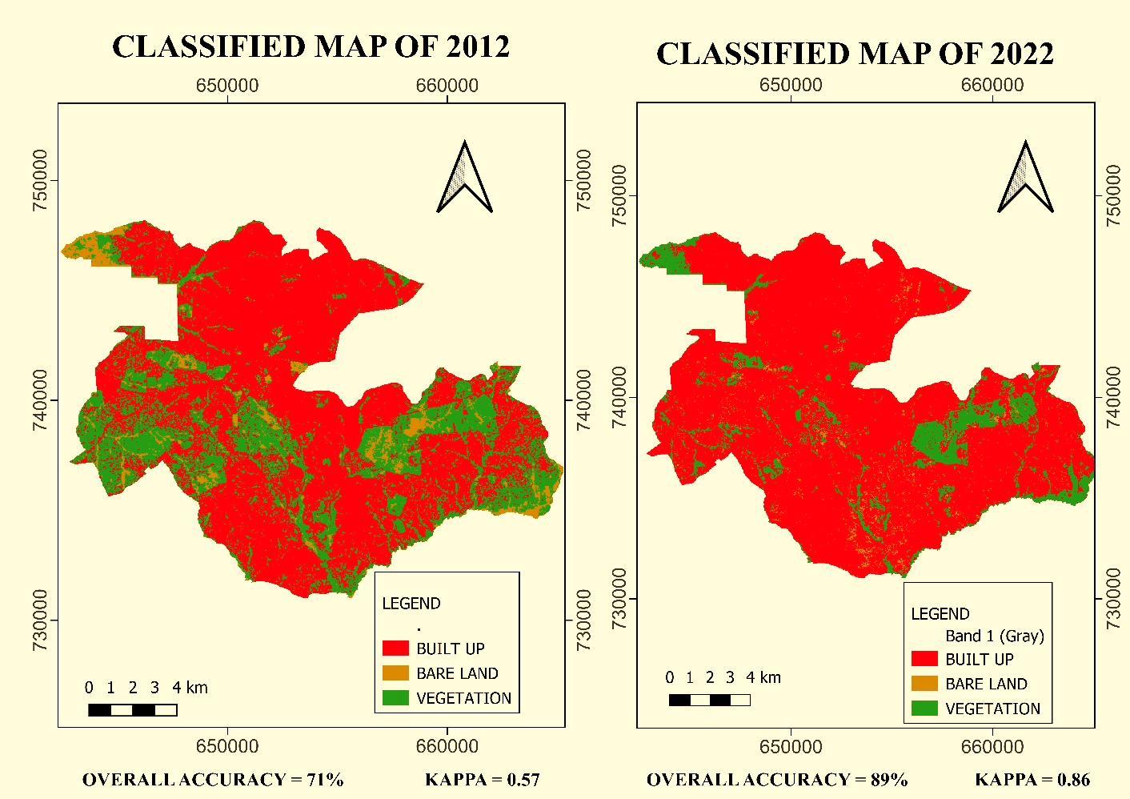

Figure 4.1 Supervised Classified Map of LULC

The ramifications of these land use modifications are profound. Notably, we found that the expansion human settlements corresponded with a rise in Land Surface Temperature (LST). This is attributable to the typically lower albedo and higher thermal conductivity of man-made surfaces compared to vegetated areas, leading to what is commonly known as urban heat islands. These are areas, particularly in urban regions, that experience higher temperatures than their poorly developed surroundings.

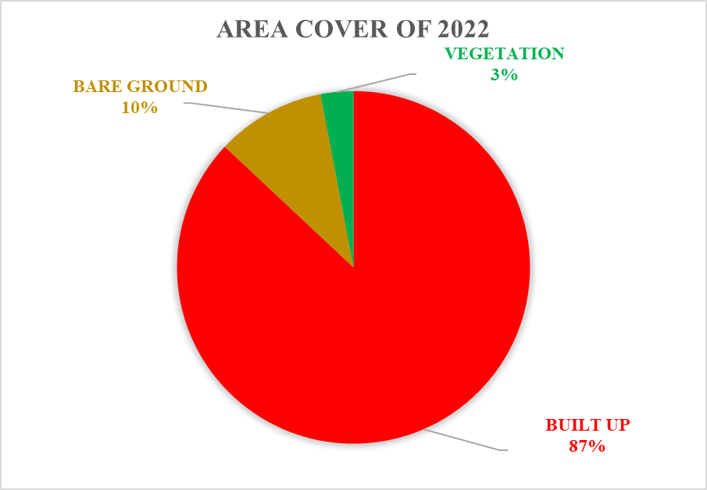

Figure 4.2 Area Covered by LUCL Classes

Figure 4.3 Graph of the area covered plotted against LULC classes

## 4.3 LST Variations

The initial high concentration of LST in a specific town in 2012 likely points to an urban heat island (UHI) effect (See figure 4.4). This phenomenon occurs when a metropolitan area is significantly warmer than its surrounding rural areas due to human activities, leading to high LST values clustered around urbanized regions. The lower albedo (reflectivity) of human-made surfaces in towns, such as concrete and asphalt, and the absence of vegetation are key factors causing these higher temperatures. The subsequent dispersion of LST values across the study area by 2022 implies a considerable expansion of urbanized, or human-impacted, areas over the decade.

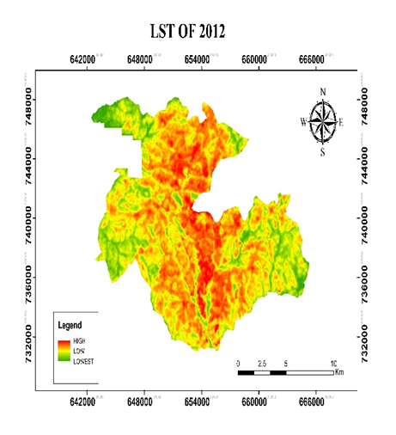 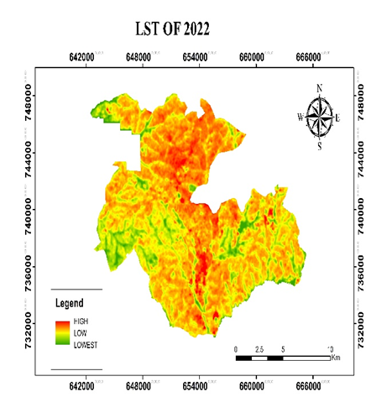

Figure 4.4 Classified map of LST of KMA

This is in line with our observed increase in settlements and bare land during the same period (See figure 4.5). As more land is developed and converted into settlements or bare land, natural vegetation is reduced, which results in a wider distribution of increased LST values. This expansion of high LST areas could have significant implications. For one, it suggests a growing UHI effect, not just in the specific town where it was initially observed, but across a larger region. This can have adverse impacts on local climates, exacerbating heat waves and increasing energy consumption due to heightened demands for cooling.

Figure 4.5 Variations of LSTs in Different Land Covers

## 4.4 Relationship between LULC and LST

The graph in Figure 4.6 depicts the average Land Surface Temperature (LST) values corresponding to various land covers between 2012 and 2022. The variance in Land Surface Temperature (LST) is impacted by the various land cover types due to reflectance differences among these land coverings. Land cover concentration or density varies, resulting in varied land surface temperatures (LST) across different regions within each land cover category. The built-up area had the highest average ground Surface Temperature (LST) of 28.768 °C in 2012, followed by bare ground with an LST of 27.673 °C. The vegetation, on the other hand, had the lowest average LST of 26.164 °C. Built-up regions had the highest average ground Surface Temperature (LST) in 2022, at 29.377 °C, followed by bare ground at 28.327 °C and vegetation at 26.66 °C. Between 2012 and 2022, the mean land surface temperature (LST) increased by 0.609 °C, 0.654 °C, and 0.496 °C for the built-up area, bare land, and vegetation, respectively.

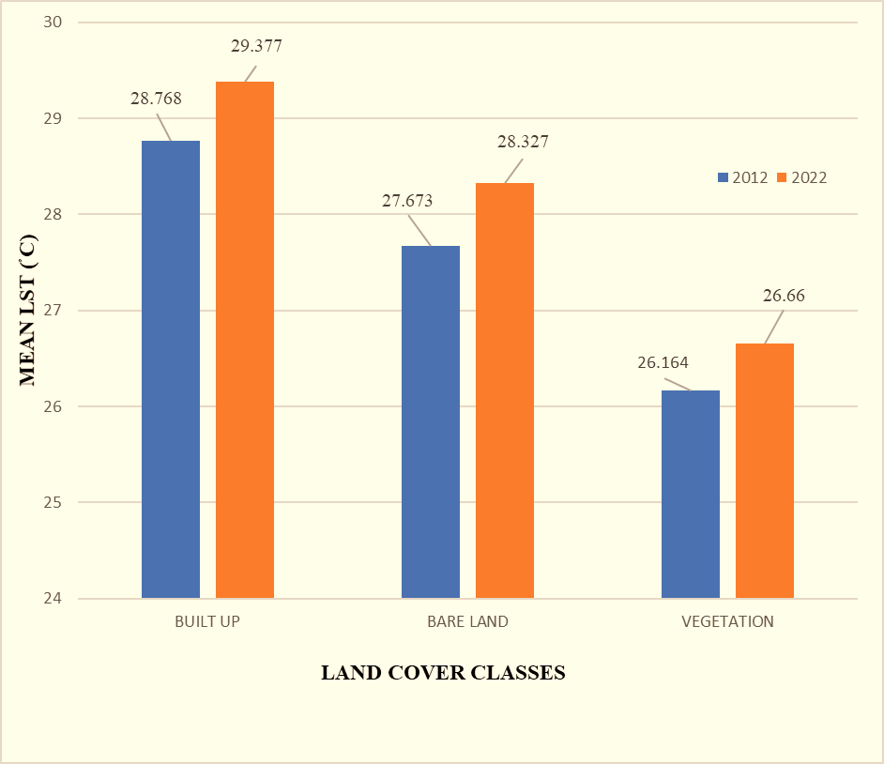

Figure 4.6 Graph depicting the Relationship Between mean LST and Land Cover Indices

## 4.5 NDVI Relationship with LST

The amount to which there is a variance in Land Surface Temperature (LST) is dependent on the many different forms of land cover that are present. According to the findings that were presented by Weng (2001), it is essential to make use of the thermal signature that is connected to each type of land cover in order to investigate the effects that land cover change has on the land surface temperature (LST). As a consequence of this, the relationship between Land Surface Temperature (LST) and a variety of indices of land cover, such as the Normalized Difference Vegetation Index (NDVI). The spatial distribution of the Normalized Difference Vegetation Index (NDVI) is shown for the years 2012 and 2022 in Figure 4.7 The significant decline in the Normalized Difference Vegetation Index (NDVI) that occurred between the years 2012 and 2022 is of special concern. The association between Land Surface Temperature (LST) and land cover indices is illustrated in Figure 4.7, and it is supported with an equation that describes the correlation. As shown in Figure 4.7, it is essential to point out that there was a negative association between NDVI and LST.

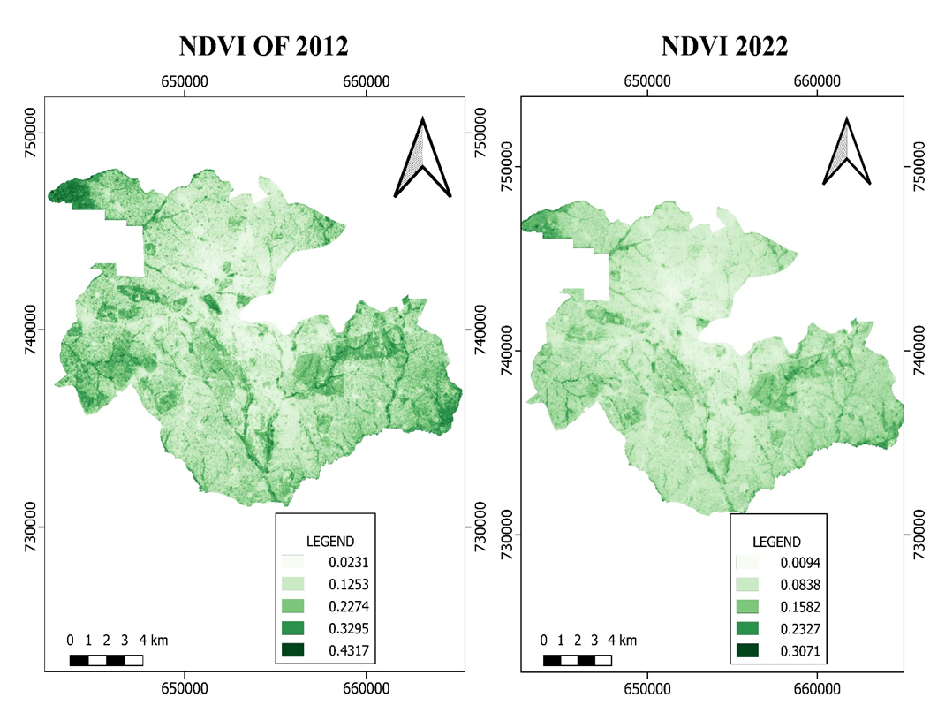

Figure 4.7 NDVI Maps for the years 2012 and 2022

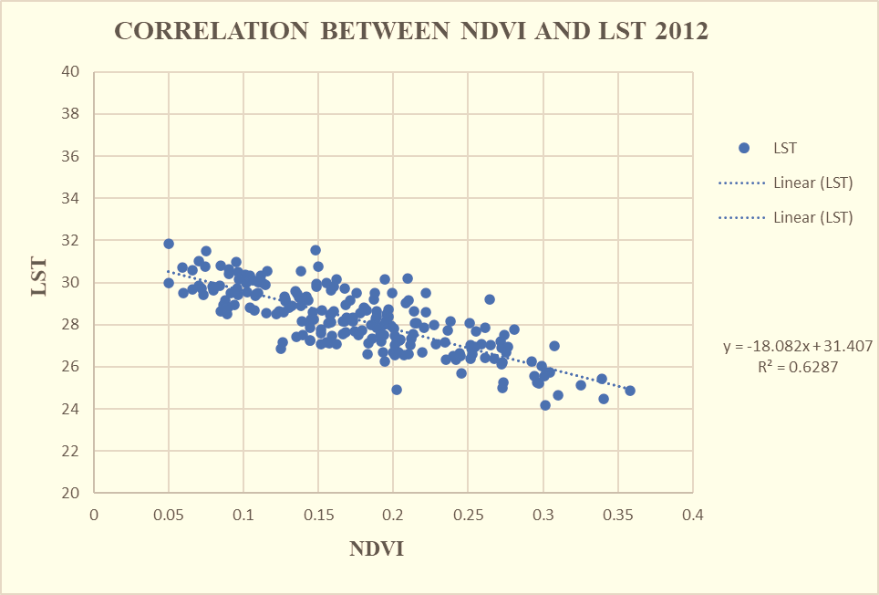

Figure 4.7 Correlation map of NDVI against LST , 2012

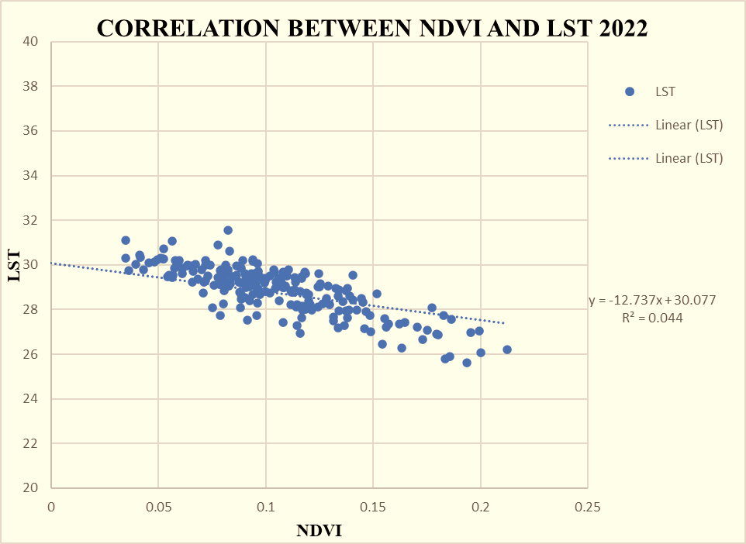

Figure 4.7 Correlation map of NDVI against LST, 2022

## 4.5 Accuracy Assessment

Land cover maps are typically subject to certain errors arising from classification methods and image acquisition techniques. In this study, the overall accuracies for the land cover maps from 2012 and 2022 were found to be 71.67% and 89.00% respectively (See Table 4.1). These accuracies surpass the usual benchmark of 70%, as proposed by Congalton (2001), indicating a relatively high level of reliability in the data.

Table 4.1 Validation and Accuracy Assessment

|  |  |  |  |  |  |  |  |  |
| --- | --- | --- | --- | --- | --- | --- | --- | --- |
| YEAR | User's accuracy (%) | | | Producer's accuracy (%) | | | Overall accuracy (%) | Kappa coefficient |
| Built-up area | Bare land | vegetation | Built-up area | Bare land | vegetation |
| 2012 | 62.5 | 70 | 88.89 | 100 | 35 | 80 | 71.67 | 0.5750 |
| 2022 | 86.96 | 85.71 | 100 | 100 | 85.71 | 85 | 89.00 | 0.8600 |

The Kappa coefficients for the same years were calculated as 0.86 and 0.57. According to Congalton (2001), a Kappa coefficient ranging between 0.40 and 0.85 denotes an excellent agreement between images, suggesting that our classifications are reliable. The accuracy of study classifications was potentially enhanced by the use of recent, high-resolution reference photos. For accuracy assessment, the study used Landsat 7 high-resolution remote sensing images to compare the derived land cover maps against Google Earth remote sensing images taken at various random sites within the study area.

## 4.6 Discussion of Findings

The study's first objective aimed at classifying the Land Use and Land Cover (LULC) within the KMA region. This classification made use of advanced techniques and high-resolution satellite imagery, allowing for the successful identification of LULC categories, including bare land, built-up areas, and vegetation. The resultant shift towards an increase in settlements over time, accompanied by a decrease in vegetated areas and bare land, reflects a significant transformation in the land use landscape. This could be attributed to factors like urban expansion, industrial development, or land clearance activities. The objective was to investigate the effect of these LULC changes on Land Surface Temperature (LST). The data suggest a distinct correlation between the two. Specifically, the rise in built-up areas, typically associated with urbanization, seems to have a pronounced effect on LST, leading to increased temperatures. This finding aligns with the urban heat island (UHI) effect concept, where urban regions, characterized by surfaces with low albedo like concrete and asphalt, tend to have higher temperatures than rural areas with vegetation cover. On the other hand, the observed reduction in vegetation could affect local climatic conditions, potentially leading to increased soil erosion and further elevating LST. Therefore, a balance of green cover and built-up areas is critical in regulating local temperature levels. The third objective involved detecting LULC changes over time by comparing LULC maps. This analysis unveiled a notable trend toward greater urbanization. More importantly, the high LST areas were no longer clustered in a single town but rather dispersed throughout the larger study region. This increased spread indicates an expanding UHI effect which, if unchecked, could pose serious challenges for climate adaptation and urban planning strategies.

# CHAPTER FIVE

# CONCLUSION AND RECOMMENDATIONS

## 5.1 Conclusion

The goal of this research was to look at the effects of changes in land use and land cover on land surface temperature (LST) in the Greater Kumasi region from 2012 to 2022. To evaluate the extent of the association between land surface temperature (LST) and two land cover indices, a regression research was done. The land cover in the Greater Kumasi area has changed significantly in recent years as a result of increased urbanization and improved socioeconomic conditions. It was discovered during the research period that the presence of vegetation had a substantial impact on the expansion of built-up areas, resulting in a 20% increase. Furthermore, the amount of bare terrain regions decreased by 3%. The urbanized region witnessed a large increase in the outer margins and northern sector of the city, which led to the replacement of a considerable percentage of naturally vegetated spaces with newly created built up areas. This resulted in the loss of a significant amount of green space. The growth of metropolitan areas has altered the radiative qualities of the surface, which has caused an imbalance in the surface energy budget. These changes have been brought about by an increase in surface heat radiation. As a direct result of this, the Land Surface Temperature (LST) has been affected, and recent observations indicate that it is continuing its upward trajectory. A geographical distribution of the maximum and mean Land Surface Temperature (LST) was discovered as a result of an investigation that was carried out in the Greater Kumasi area. The data suggested that there was a rise of 2.305 degrees Celsius and 0.649 degrees Celsius throughout the course of the research. However, it was determined that the change in the mandatory LST was not substantial. The growth of metropolitan areas and undeveloped territory has led to a rise in the land area occupied by climate zones with higher average temperatures. It is important to point out that regardless of the exact land cover type, the average temperature of the land's surface, also known as the LST, displayed a moderate rising trend between the years 2012 and 2022. At the very least, a portion of the observed occurrence can be ascribed, in whole or in part, to the impact of the changing climate. However, further research is necessary to corroborate the conclusion that built-up areas and bare land had greater land surface temperatures (LST), whereas vegetation exhibited the lowest LST. This is because built-up areas and bare land both demonstrated higher LSTs. The rise in land surface temperature (LST) that has been seen over a period of time may largely be linked to the process of urbanization as it has taken place. In the end, the research results suggest that there is an inverse relationship between NDVI and LST. According to the facts indicated above, it is very necessary for the decision-makers in Greater Kumasi to make the problem of upcoming urban growth a priority, ensuring that they take into account both the horizontal and the vertical dimensions. In addition, it is of the utmost importance for them to design a complete plan that incorporates ecologically friendly construction procedures. Some examples of these activities are green building techniques and the deployment of cool roof technology. The use of this strategy will successfully alleviate the negative impacts of the warming of the urban microclimate. It is strongly advised that growth control plans be proposed as a method of mitigating the problem of urban heat islands that is related with the temperature of the land surface.

## 5.2 Summary of Findings

In the upcoming presentation, the goal is to offer a condensed and accurate overview of the inferences that have been drawn from the data that has been provided up until this point, along with the further analysis that will be presented. The results of the study suggest a significant rise (20%) in the growth of urban or built-up areas as a direct consequence of the conversion of areas that were previously covered in vegetation into urban or built-up zones. This phenomenon might be ascribed to the requirement for expanded spatial capacity in metropolitan or developed regions in order to allow the expansion of these places. The result that was arrived at by using the procedure described above may be stated as follows. Because of this phenomenon, there was a discernible expansion in the geographical range of the region that displayed higher temperatures. This took place in a number of different locations. Built-up areas and bare ground exhibited higher values of land surface temperature (LST) in contrast to other types of land cover; nonetheless, vegetation consistently demonstrated the lowest LST values overall years. During the course of the examination, there was a discernible rise in the temperature of the land's surface, which was measured as LST, of 2.305 degrees Celsius. The land surface temperature (LST) increased gradually but steadily throughout the course of the study's period, and this trend was observed across all types of land cover. This study presents factual evidence of the influence that urban microclimate warming has had in the Greater Kumasi region. There is a connection between the rising rate of urbanization and the land surface temperature (also known as LST). This hyperlink has the potential to either be beneficial or harmful to the user. On the other hand, researchers have shown that the Land Surface Temperature (LST) and the Vegetation Index (NDVI) are negatively correlated with one another.

## 5.2 Recommendations

1. The creation of green spaces inside urban environments, such as parks, community gardens, green roofs, and street trees, has the potential to effectively offset the urban heat island effect by decreasing surface temperatures. This is the case because green areas absorb more heat than paved surfaces do. The ability of urban surroundings to absorb solar radiation and effectively release thermal energy through the process of transpiration is a benefit of living in an urban setting.
2. The application of ideas about ecological compatibility and economic viability to the practice of urban planning and design has the potential to yield significant advantages. The exploitation of materials with high albedo features in the construction of buildings and roads, the establishment of open spaces, and the decrease in building density are all effective options for decreasing the temperature of the land's surface.
3. It is well known that the processes of afforestation and reforestation have the ability to bring about a reduction in the average temperature of the land's surface. This is accomplished by making use of the sun's energy and the trees' capability to absorb it. It is possible to lessen the impact of a rise in land surface temperature (LST) by concentrating on activities that encourage reforestation and afforestation, particularly in built-up regions and their surrounding suburbs.
4. The implementation of effective techniques for the management of watersheds, such as the preservation of resilient riparian zones, can play a role in the regulation of Land Surface Temperature (LST) by fostering hydrological equilibrium within the region. This can be accomplished via the application of efficient watershed management strategies.
5. The growth of urban areas and the accompanying rise in land surface temperature (LST) can be somewhat mitigated by the utilization of urban planning strategies such as the imposition of urban growth limitations and other rules of a comparable nature.
6. In agricultural regions, the implementation of farming techniques such as agroforestry, which involves the combined cultivation of crops and trees, as well as the adoption of cover crops, has shown promise in mitigating the negative impacts of land surface temperature (LST). This is because agroforestry involves the combined cultivation of crops and trees.
7. The introduction of severe land use rules that successfully limit undesirable land use and land cover changes, such as excessive urbanization and deforestation, can result in large benefits if these policies are followed to the letter. In this regard, the implementation of zoning restrictions within urban contexts that mandate a particular allocation of green space might potentially provide help.
8. The use of permeable materials in urban infrastructure, such as permeable concrete or asphalt for pavements and parking lots, provides enhanced water absorption, which in turn helps to contribute to a reduction in the temperature of the local surface.
9. The employment of cool roofs and walls, which are purposely intended to maximize solar reflection and restrict heat absorption, shows promise for lowering energy consumption and lowering local surface temperatures (LST). Cool roofs and walls are purposefully constructed to optimize solar reflection and limit heat absorption.

# REFERENCES

Anderson, J. R., Hardy, E. E., Roach, J. T., & Witmer, R. E. (1976). A land use and land cover classification system for use with remote sensor data. Geological Survey Professional Paper, 964, 28.

Bellouin, N., Quaas, J., Morcrette, J. J., & Boucher, O. (2013). Estimates of aerosol radiative forcing from the MACC re-analysis. Atmospheric Chemistry and Physics, 13(4), 2045-2062.

Blume, H. P., Brümmer, G. W., Fleige, H., Horn, R., Kandeler, E., Kögel-Knabner, I., ... & Wiesmeier, M. (2016). Scheffer/Schachtschabel soil science. Springer.

Bonan, G. (2008). Forests and climate change: Forcings, feedbacks, and the climate benefits of forests. Science, 320(5882), 1444-1449.

Bonan, G. B. (2002). Ecological climatology: Concepts and applications. Cambridge University Press.

Carlson, T. N., & Ripley, D. A. (1997). On the relation between NDVI, fractional vegetation cover, and leaf area index. Remote Sensing of Environment, 62(3), 241-252.

Dutta, D., Kundu, A., Patel, N. R., Saha, S. K., & Siddiqui, A. R. (2015). Assessment of agricultural drought in Rajasthan (India) using remote sensing derived Vegetation Condition Index (VCI) and Standardized Precipitation Index (SPI). The Egyptian Journal of Remote Sensing and Space Science, 18(1), 53–63.

Foley, J. A., DeFries, R., Asner, G. P., Barford, C., Bonan, G., Carpenter, S. R., ... & Helkowski, J. H. (2005). Global consequences of land use. Science, 309(5734), 570-574.

Foody, G. M. (2015). Land Use and Land Cover (LULC) Classification Using Remote Sensing. Progress in Physical Geography: Earth and Environment, 30(1), 3–22.

Gaston, K. J., Ávila-Jiménez, M. L., & Edmondson, J. L. (2013). Review: Managing urban ecosystems for goods and services. Journal of Applied Ecology, 50(4), 830–840.

IPCC, (2014). Climate Change 2014: Synthesis Report. Contribution of Working Groups I, II and III to the Fifth Assessment Report of the Intergovernmental Panel on Climate Change [Core Writing Team, R.K. Pachauri and L.A. Meyer (eds.)]. IPCC, Geneva, Switzerland.

Jiang, L., & O'Neill, B. C. (2017). Global urbanization projections for the Shared Socioeconomic Pathways. Global Environmental Change, 42, 193–199.

Jones, H. G., & Vaughan, R. A. (2010). Remote sensing of vegetation: Principles, techniques, and applications. Oxford University Press.

Khandelwal, S., Goyal, R., Kaul, N., & Mathew, A. (2017). Urban heat island and its relationship with land use/land cover and nighttime lights in Jaipur City, India. Journal of the Indian Society of Remote Sensing, 45(4), 603-613.

Kuenzer, C., & Dech, S. (2013). Theoretical background of water surface mapping. In Water Remote Sensing (pp. 1–19). Springer.

Kustas, W. P., & Anderson, M. C. (2009). Advances in thermal infrared remote sensing for land surface modeling. Agricultural and Forest Meteorology, 149(12), 2071-2081.

Lambin, E. F., & Meyfroidt, P. (2011). Global land use change, economic globalization, and the looming land scarcity. Proceedings of the National Academy of Sciences, 108(9), 3465-3472.

Li, H., Wang, D., Liu, Y., Zhang, L., & Li, L. (2017). Urban land use and land cover change: A case study in the city of Lanzhou, China. Landscape and Urban Planning, 170, 217–227.

Lillesand, T., Kiefer, R. W., & Chipman, J. (2014). Remote Sensing and Image Interpretation. John Wiley & Sons.

Malmir, M., Attarod, P., Marvi Mohajer, M. R., Zahedi Amiri, G., Fathi, P., & Shirvany, A. (2016). Influences of environmental variables on the distribution of forest types in the northern forests of Iran. Forest Science and Practice, 18(3), 215-224.

Mekonnen, A., Keesstra, S., Baartman, J., Maroulis, J., & Stroosnijder, L. (2015). Wind and water erosion and their spatial connectivity in the Netherlands. Geomorphology, 228, 826-839.

Nettels, J. J., & Jones, J. R. (2010). Effect of light on growth and pigment content of Myriophyllum spicatum and Potamogeton crispus. Freshwater Biology, 55(2), 406-418.

Oke, T. R. (1987). Boundary layer climates. Methuen.

Pickett, S. T., Cadenasso, M. L., Grove, J. M., Boone, C. G., Groffman, P. M., Irwin, E., ... & Warren, P. (2011). Urban ecological systems: scientific foundations and a decade of progress. Journal of environmental management, 92(3), 331-362.

Seto, K. C., Güneralp, B., & Hutyra, L. R. (2012). Global forecasts of urban expansion to 2030 and direct impacts on biodiversity and carbon pools. Proceedings of the National Academy of Sciences, 109(40), 16083–16088.

Shahid, S. (2019). Impacts of climate change on the future of biodiversity. Ecosystems and the Biosphere, 1-18.

Sherwood, S., & Fu, Q. (2014). A drier future?. Science, 343(6172), 737-

Stewart, I. D., & Oke, T. R. (2012). Local climate zones for urban temperature studies. Bulletin of the American Meteorological Society, 93(12), 1879-1900.

Su, Z. (2002). The Surface Energy Balance System (SEBS) for

Top of Form